DEVELOPMENT OF A PROACTIVE DECISION SUPPORT SYSTEM FOR KNOWLEDGE LOSS RISK AND TRANSFER DURING ORGANIZATIONAL TRANSITIONS

Sanda Dewage Puwakgaha Ele Gedara Shanuka Samintha Jayakodi
Bachelor of Science in Management Information Systems (Special)

Department of Information Systems
Faculty of Computing
NSBM Green University
Sri Lanka

October 2026

DEVELOPMENT OF A PROACTIVE DECISION SUPPORT SYSTEM FOR KNOWLEDGE LOSS RISK AND TRANSFER DURING ORGANIZATIONAL TRANSITIONS

A thesis submitted to NSBM Green University for the degree of Bachelor of Science in Management Information Systems (Special)

By

Sanda Dewage Puwakgaha Ele Gedara Shanuka Samintha Jayakodi

Department of Information Systems
Faculty of Computing
NSBM Green University
Sri Lanka

October 2026

DECLARATION

I declare that the content of this undergraduate thesis titled Development of A Proactive Decision Support System For Knowledge Loss Risk Assessment And Knowledge Transfer During Organizational Transitions is my own work and this dissertation does not incorporate without acknowledgement any material previously submitted for any other degree in any university or institution of higher learning.

Signature: …………………. ………..………………
Name: …………………………………………. Date

Signature of the Supervisors
.…………………………

Dr./Mr./Ms. ……………………………….,
Principal Supervisor
Senior Lecturer/Lecturer
Department of …………………………………………….,
NSBM Green University

ACKNOWLEDGEMENT

I would like to express my sincere gratitude to my research supervisor, Miss Dharani Rajasinghe, for the guidance, constructive feedback and encouragement provided throughout this research. Their advice helped me refine the research direction, address challenges and improve the quality of this thesis.
I also extend my appreciation to the academic staff of the Faculty of Computing at NSBM Green University for the knowledge and support provided throughout my degree programme. The skills and understanding gained during my studies formed an important foundation for the design and development of KnowledgeGuard.
My sincere thanks go to the participants and industry professionals who contributed their time and insights to the research questionnaires and system evaluation. Their contributions helped inform the assessment and evaluation of the proposed system.
I am grateful to my friends and colleagues for their encouragement, helpful discussions and support during the development of the system and preparation of this thesis.
Finally, I would like to thank my family for their patience, understanding and continuous encouragement throughout my academic journey. Their support gave me the motivation to persevere through challenges and complete this research.

ABSTRACT

Employee transitions can disrupt important work when specialized knowledge is concentrated in one person and suitable documentation or backup staff are unavailable. This study developed KnowledgeGuard, a web-based decision support prototype for assessing knowledge-loss risk and coordinating knowledge transfer. Following a design science approach, the system assesses expertise uniqueness, documentation gap, project criticality, collaboration dependency, and tenure. It combines an indicator-based score with manager assessment and a supporting machine-learning score. Managers can initiate a structured knowledge-transfer plan for cases classified as high or critical risk.
The prototype was demonstrated using 30 anonymized standalone assessment responses from industry colleagues and a separate generated Q1-Q4 workflow dataset. Ten system evaluators gave a mean System Usability Scale score of 89.50 (SD = 3.07); mean perceived usefulness, ease of use and behavioral intention were 4.43, 4.53 and 4.60. An exploratory aggregation of ten pairwise responses produced a consistent AHP group matrix (CR = 0.0822), but proposed weights different from the predefined baseline. The baseline remained active for all reported scoring demonstrations. These results support prototype functionality and favorable descriptive feedback, not predictive validity or measured reduction of knowledge loss.
KnowledgeGuard demonstrates how risk assessment can be linked to managed knowledge-transfer activities. The generated assessments are not observations from a real organization, and the evaluation does not establish predictive accuracy or lasting knowledge retention. Organizational assessments over time are needed to evaluate those outcomes.

TABLE OF CONTENTS

DECLARATION i
ACKNOWLEDGEMENT ii
ABSTRACT iii
TABLE OF CONTENTS iv
LIST OF FIGURES ix
LIST OF TABLES x
LIST OF ABBREVIATIONS xi
1. INTRODUCTION 1
1.1 Chapter overview 1
1.2 Background 1
1.3 Problem statement 1
1.4 Research gap 2
1.5 Research questions 3
1.6 Research motivation and significance 3
1.7 Scope 3
1.8 Overview of the the praposed solution 5
1.9 Chapter summary 5
2. OBJECTIVES 6
2.1 General objective or aim 6
2.2 Specific objectives 6
3. LITERATURE REVIEW 7
3.1 Chapter overview 7
3.2 Domain concepts and theories 7
3.2.1 Organizational knowledge, tacit knowledge and knowledge-loss risk 9
3.3 Existing studies, systems or frameworks 9
3.3.1 Repositories versus proactive decision support 9
3.3.2 Limitations of self-reported assessment data 10
3.3.3 The gap between risk identification and mitigation 10
3.3.4 Comparison with related systems and frameworks 10
3.4 Technical approaches 11
3.4.1 Operationalization of knowledge-loss indicators 11
3.4.2 Transparent weighted scoring and AHP 13
3.4.3 Supporting machine learning and anomaly review 13
3.4.4 Generative AI and knowledge-transfer planning 14
3.4.5 Design-science evaluation, SUS and TAM 14
3.5 Research gap and implications for this work 15
3.6 Chapter summary 15
4. METHODOLOGY 16
4.1 Research design 16
4.2 Data, participants and stakeholders 16
4.3 Requirements and analysis 18
4.3.1 Non-functional requirements 20
4.4 Proposed design 20
4.4.1 Components, actors and data flow 20
4.4.2 From assessment response to indicator score 25
4.4.3 Formula, manager and machine-learning scores 26
4.4.4 From risk review to knowledge transfer 30
4.5 Development and implementation procedure 32
4.6 Evaluation procedure 32
4.7 Ethics and project management 34
4.8 Chapter summary 35
5. RESULTS 36
5.1 Chapter overview 36
5.2 Evaluation data 36
5.3 Prototype outputs and workflow demonstration 37
5.3.1 Assessment and manager validation 37
5.3.2 Knowledge-transfer planning and tasks 39
5.3.3 Worked knowledge-transfer score trace 41
5.4 Functional verification and implementation evidence 42
5.5 AHP results 43
5.6 Generated quarterly score history 45
5.7 Usability and acceptance results 45
5.8 Supporting machine-learning results 46
5.9 Results against the objectives 48
5.10 Chapter summary 48
6. DISCUSSION AND CONCLUSIONS 49
6.1 Chapter overview 49
6.2 Discussion of the research questions 49
6.2.1 RQ1: Operationalizing knowledge-loss risk 49
6.2.2 RQ2: Integrating assessment, manager judgement, and ML 49
6.2.3 RQ3: Supporting knowledge transfer 50
6.2.4 RQ4: Prototype evaluation 51
6.3 Comparison with the literature 51
6.4 Research and practical contribution 52
6.5 Limitations 52
6.6 Future work 53
6.7 Conclusions 54
REFERENCES 55
Appendix A: Assessment questionnaires 58
Appendix B: Expert pairwise-comparison form 65
Appendix C: System-evaluation questionnaire 67
Appendix D: Participant information and approvals 69
Appendix E: Functional test cases 70
Appendix G: Worked scoring examples and weights 80

LIST OF FIGURES

Figure 1.1: Overview of the proposed KnowledgeGuard workflow
Figure 3.1: Conceptual map of the literature informing KnowledgeGuard
Figure 4.1: KnowledgeGuard architecture and principal data flows
Figure 4.2: Class diagram and principal data relationships in KnowledgeGuard
Figure 4.3: Use-case diagram for role-based KnowledgeGuard interactions
Figure 4.4: Activity diagram for assessment, validation and knowledge transfer
Figure 4.5: Supporting machine-learning score process in KnowledgeGuard
Figure 4.6: Sequence diagram for risk assessment and manager validation
Figure 5.1: Preliminary risk profile for a synthetic demonstration record before manager validation.
Figure 5.2: The same synthetic risk profile after manager validation.
Figure 5.3: Knowledge-transfer plan creation for a fictional eligible holder and backup.
Figure 5.4: Five knowledge-transfer task types created for a synthetic demonstration plan.
Figure 5.5: Consistent aggregated AHP group matrix with CR = 0.0822.
Figure 5.6: Quarterly score history for a fictional identity using generated Q1–Q4 inputs.
Figure 5.7: SUS results for the ten system evaluators.
Figure 5.8: Mean TAM construct ratings from ten evaluators.

LIST OF TABLES

Table 1.1: Scope and evidence boundaries
Table 3.1: Related systems and frameworks compared with KnowledgeGuard
Table 3.2: Literature basis for the KnowledgeGuard indicators
Table 4.1: Data sources and permitted interpretations
Table 4.2: Stakeholders and their roles in the workflow
Table 4.3: Functional requirements and observable checks
Table 4.4: KnowledgeGuard indicators and predefined baseline weights
Table 4.5: Supporting machine-learning design
Table 4.6: Configured operational risk tiers
Table 4.7: Evaluation measures and required evidence
Table 4.8: Generated quarterly questionnaire design
Table 5.1: Evaluation sources and their permitted interpretation
Table 5.2: Simulated knowledge-transfer score trace
Table 5.3: Functional verification and implementation evidence
Table 5.4: Predefined baseline and exploratory AHP group weights
Table 5.5: System-evaluation questionnaire summaries
Table 5.6: Saved ML metrics and interpretation
Table 5.7: Results against the Chapter 2 objectives

LIST OF ABBREVIATIONS

Abbreviation | Description
AHP | Analytic Hierarchy Process
API | Application Programming Interface
CD | Collaboration Dependency
CI | Consistency Index
CR | Consistency Ratio
CSV | Comma-Separated Values
DG | Documentation Gap
DSS | Decision Support System
EU | Expertise Uniqueness
KT | Knowledge Transfer
ML | Machine Learning
PC | Project Criticality
SUS | System Usability Scale
T | Tenure
TAM | Technology Acceptance Model

1. INTRODUCTION

1.1 Chapter overview
This chapter introduces the problem of knowledge loss during employee transitions and explains why an assessment linked to knowledge-transfer action is needed. It presents the problem, research gap, questions, significance, scope, and proposed solution.

1.2 Background
Organizations depend on knowledge held in documents, systems, work routines, and employees’ experience. Some knowledge can be recorded as instructions. Other knowledge develops through practice and judgement and may be difficult to express fully in a document. The distinction between explicit and tacit knowledge helps explain why access to documentation does not always enable another employee to perform a specialist’s work [1].
Resignation, retirement, role change, or extended absence can create a continuity risk. Its importance depends on the knowledge involved, the available documentation, the work supported by the employee, and whether another person can take over the relevant tasks. Organizational knowledge transfer requires knowledge to become usable by other people, beyond merely storing information [2].
A systematic review of 74 studies distinguished knowledge-loss drivers, effects, and mitigation, finding that much published work addresses losses already under way [3]. Recent case studies also link disruption to weak sharing of personal knowledge and show that job shadowing can form part of retention practice [4]. These findings justify looking for exposed work before a transition and specifying who will receive and practise the knowledge; they do not establish the prevalence of this problem in the demonstration dataset.
KnowledgeGuard is a decision support prototype designed to identify cases requiring attention, present assessment information for manager review, and coordinate action involving a knowledge holder and a backup employee. Its risk score summarizes defined indicators. It does not directly measure the probability of departure or actual future knowledge loss.

1.3 Problem statement
Organizations may struggle to identify which employee transitions require urgent knowledge-transfer preparation. Relevant information can be spread across employees, managers, documents, and operational processes. A manager may know that an employee is important yet lack a consistent way to assess why the employee’s absence would cause difficulty or whether a backup is ready.
Specialized expertise may be concentrated in one person while instructions remain incomplete. Project importance, dependency, and replaceability can vary independently. An assessment must therefore consider more than tenure or departure status. Automated scoring can apply the same rules across cases, but a manager may know circumstances absent from recorded responses. Identifying a risk is also only the start: a response requires transfer activities and an assessment of backup competence.
Research on knowledge loss identifies workforce transitions, limited knowledge sharing, and inadequate retention practices as sources of organizational exposure [3], [4]. These findings support the need for a structured assessment linked to transfer preparation.
The central problem is how a decision support system can help identify employee-level knowledge-loss risk and support structured knowledge-transfer decisions during organizational transitions.

1.4 Research gap
Existing research explains knowledge-loss risks and identifies retention practices, including documentation, knowledge sharing, and job shadowing [3], [4], [6]. However, these findings do not by themselves demonstrate how an employee-level assessment can be connected to manager review, assigned transfer activities, and documented assessment of backup competence within one evaluated application. This study investigates that integration through the KnowledgeGuard prototype.
This study does not claim to invent a new theory of knowledge transfer, or that no similar product exists. Its contribution is the design, implementation, and limited evaluation of KnowledgeGuard, a prototype that links employee-level risk assessment to manager review and assigned transfer activities.
In design science, a working artefact and its evaluation need to be described clearly [5]. Here the artefact is the implemented assessment-to-transfer workflow; the design insight concerns how to link explainable indicators, review, and assigned transfer tasks under explicit evidence limits.
The gap is also practical. Research identifies useful transfer mechanisms, but shows that sector and work context shape retention [6], so a generic score needs local testing. This project tests whether assessment, review and transfer can be joined in one traceable prototype. Validating real-world outcomes is left to future organizational study.

1.5 Research questions
The main research question is: How can a decision support system help identify employee-level knowledge-loss risk and support structured knowledge-transfer decisions during organizational transitions?
- RQ1. How can literature-informed indicators of employee-level knowledge-loss risk be operationalized in a structured prototype assessment?
- RQ2. How can indicator-based assessment, manager judgement, and supporting machine-learning analysis be integrated into a decision support workflow?
- RQ3. How can the system support the planning, completion, and review of knowledge-transfer activities after a high-risk case is identified?
- RQ4. How usable and acceptable is the prototype to its evaluators, and which aspects of its intended workflow can be demonstrated through testing?

1.6 Research motivation and significance
The practical motivation is to help managers identify important knowledge dependencies before a transition disrupts work. A structured assessment can make the reasons for prioritization visible; a linked transfer plan can direct attention to documentation, observation, discussion, and practice. The system remains a support for human judgement rather than an autonomous employment decision.
The research significance lies in examining whether established methods can be connected into one auditable workflow. Design science research supports building and evaluating an information-system artefact in response to a practical problem [5]. The value demonstrated in this study concerns the prototype and its evaluated functions (see Section 1.7).

1.7 Scope
KnowledgeGuard assesses employee-level knowledge-loss risk using five indicators: expertise uniqueness, documentation gap, project criticality, collaboration dependency, and tenure. These dimensions define the study boundary; their theoretical basis and measurement are explained in Chapters 3 and 4. The prototype combines an indicator-based score, manager judgement, and a supporting machine-learning score. It supports knowledge-transfer planning for employees classified as high or critical risk, including assigned activities, knowledge-holder and backup confirmations, managerial approval, and review through a later separately imported assessment.
The study covers prototype development and evaluation using 30 anonymized standalone industry-colleague assessments, a separate generated Q1-Q4 workflow dataset, ten pairwise-comparison responses and ten system-evaluation responses. The prototype was deployed online for evaluator access, not a partner-organization field study. AHP provided an exploratory comparison with the predefined weights; it did not change the scoring configuration used in the evaluation.
The colleague responses do not constitute a representative organizational sample, and the generated Q1-Q4 dataset does not represent observations of real employees over four quarters. The evaluation therefore addresses prototype functionality, usability, and perceived acceptance; it does not establish independent real-world predictive accuracy, lasting knowledge retention, or an actual reduction in organizational knowledge loss. Risk classifications support managerial review and knowledge-transfer prioritization. Further organizational evaluation would be required to assess sustained transfer outcomes.
Table 1.1: Scope and evidence boundaries
Included in this study | Outside the demonstrated evidence
Prototype assessment and manager-reviewed KT workflow | Deployment or observed outcomes in a partner organization
Standalone colleague responses and a separate generated Q1-Q4 test dataset | A real four-quarter cohort or observed retention over time
Exploratory AHP comparisons and usability responses | Validated indicator weights or population-wide acceptance
Scoring and functional demonstration | Independent prediction of departures or knowledge loss

1.8 Overview of the the praposed solution
The workflow begins with structured assessment responses, which are processed into indicator scores and risk information for managerial review. A case needing attention may lead to a plan involving the knowledge holder, backup, and manager. The plan organizes documentation, shadowing, a structured interview, backup competence assessment, and final sign-off. Later assessments can support review of changes in calculated risk. Figure 1.1 summarizes the assessment, managerial review, knowledge-transfer, and reassessment workflow.
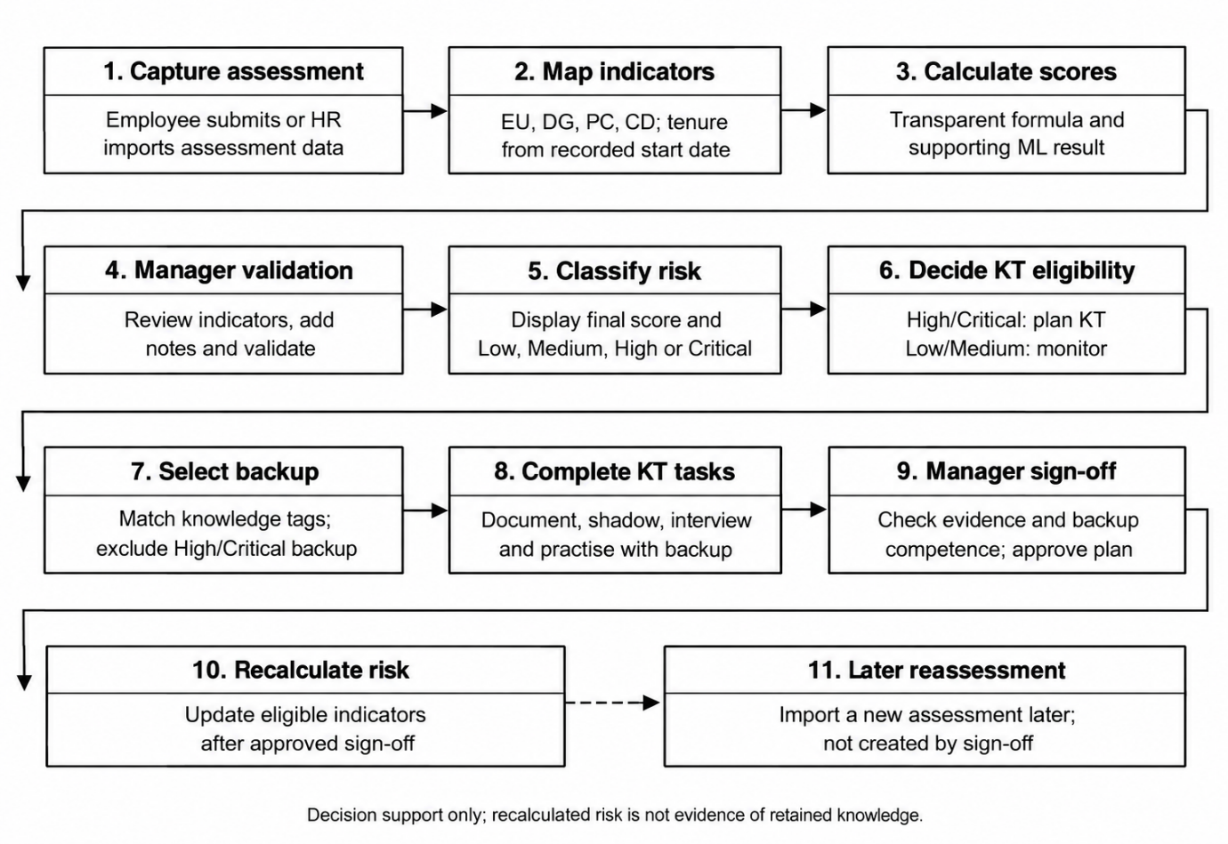
Figure 1.1: Overview of the proposed KnowledgeGuard workflow.

1.9 Chapter summary
This chapter defined the knowledge-loss problem, the study’s design contribution, four research questions, and the boundaries of the prototype evaluation. Chapter 2 states the objectives, and Chapter 3 reviews the research informing the assessment and transfer workflow.

2. OBJECTIVES

2.1 General objective or aim
The general objective of this study was to design, develop, and evaluate KnowledgeGuard, a decision support prototype that assesses employee-level knowledge-loss risk during organizational transitions and supports structured knowledge-transfer decisions.
The intended contribution is an accountable decision-support workflow, not an autonomous personnel-decision tool. KnowledgeGuard therefore shows its assessment inputs and risk information to a manager, links eligible cases to knowledge-transfer activities, and records review and approval.

2.2 Specific objectives
- Objective 1. To identify literature-informed indicators of employee-level knowledge-loss risk and operationalize them in a structured assessment that flags potentially low-quality response patterns for managerial review.
- Objective 2. To derive and justify the prototype’s design requirements from relevant knowledge-management, risk-assessment, and decision-support research.
- Objective 3. To design and implement an integrated workflow that combines transparent indicator scoring, manager validation, a supporting machine-learning score, risk classification, and knowledge-transfer planning, task review, and sign-off.
- Objective 4. To evaluate the prototype’s assessment and knowledge-transfer functions through functional testing and to describe perceived usability and acceptance from system-evaluation responses.

3. LITERATURE REVIEW

3.1 Chapter overview
This chapter reviews the literature and concepts that inform KnowledgeGuard, a decision-support prototype for identifying employee-level knowledge-loss risk and supporting knowledge-transfer planning. The review begins with organizational knowledge, tacit knowledge, and the risks created when important knowledge is concentrated in individual employees. It then examines the limitations of existing knowledge-management approaches, particularly document repositories, self-reported assessments, and approaches that identify risk without supporting follow-up transfer activities.
The chapter next explains the design basis for KnowledgeGuard: the five risk indicators, transparent weighted scoring, Analytic Hierarchy Process (AHP), response-quality checks, supporting machine learning, generative AI assistance, and knowledge-transfer activities. Finally, it synthesizes the literature to define the research gap addressed by the prototype.

3.2 Domain concepts and theories
The reviewed literature follows a progression from the broad problem of organizational knowledge to the specific decision-support workflow implemented in KnowledgeGuard. Organizational knowledge establishes the domain; tacit knowledge explains why documentation alone may be insufficient; employee transitions create potential exposure; and the identified limitations justify an integrated assessment-to-transfer workflow.
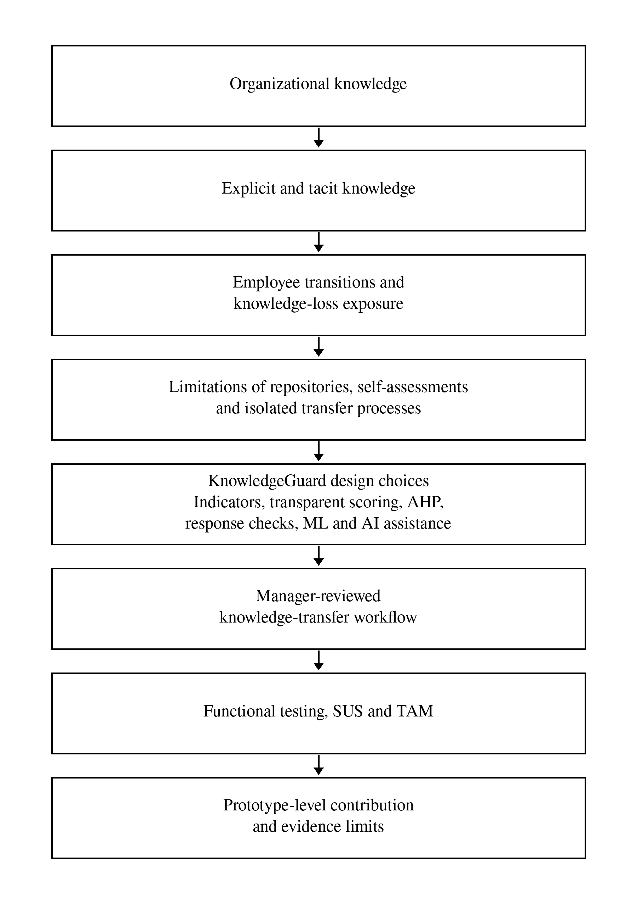
Figure 3.1: Conceptual map of the literature informing KnowledgeGuard.

3.2.1 Organizational knowledge, tacit knowledge and knowledge-loss risk
Organizational knowledge includes documented information, work routines, practical experience, technical skills, judgement, and contextual understanding used to perform work. Knowledge management concerns the creation, capture, sharing, retention, and application of this knowledge.
A central distinction is between explicit and tacit knowledge. Explicit knowledge can be documented and communicated through manuals, procedures, reports, system records, and policies. Tacit knowledge is more closely connected to personal experience, judgement, practical skill, and context [1]. An organization may retain documents after an employee leaves but still lose the ability to solve unusual problems, understand historical decisions, or perform work efficiently.
Employee transitions such as resignation, retirement, internal transfer, promotion, restructuring, or extended absence can create knowledge-loss exposure. The risk may be greater when specialized expertise is concentrated in one person, documentation is incomplete, critical work depends on that person, or colleagues frequently rely on them for support [3], [4], [7]. KnowledgeGuard treats knowledge loss as a proactive assessment and decision-support problem. It does not predict whether an employee will resign; it identifies cases where an absence could create difficulty and where transfer preparation may be appropriate.
A high risk score is not evidence that knowledge has already been lost. It is an indication that the case should be reviewed.

3.3 Existing studies, systems or frameworks

3.3.1 Repositories versus proactive decision support
Knowledge repositories and collaboration systems, such as SharePoint and Confluence, are valuable for storing documents, sharing information, and maintaining recorded knowledge [12], [13]. ServiceNow Knowledge Management also supports controlled publication and approval of knowledge articles [14]. However, repositories primarily manage knowledge that has already been captured. They do not inherently identify which employee has difficult-to-replace knowledge, determine the operational consequences of that employee’s absence, or initiate a knowledge-transfer workflow from a risk assessment.
This does not mean that repository systems are ineffective. They can support KnowledgeGuard by storing documentation created during transfer activities. The limitation is that document storage alone does not provide proactive employee-level risk assessment or confirm that a backup employee can perform the relevant work.

3.3.2 Limitations of self-reported assessment data
Structured assessments, spreadsheets, and survey platforms can collect useful employee-level information. However, self-reported answers may contain response-quality issues, such as limited variation, inconsistent interpretation, or potentially self-enhancing answers. Ward and Meade recommend prevention, screening, and transparent reporting when handling potentially careless survey responses [17].
A straight-lined or contradictory response does not prove dishonesty. It may reflect rushed completion, misunderstanding, unusual work circumstances, or limited differentiation between questions. KnowledgeGuard therefore displays response-quality flags for manager review rather than labelling an employee as dishonest. The prototype uses local rule-based checks for potentially rushed, contradictory, or self-enhancing answer patterns; these checks are not a validated lie-detection method.

3.3.3 The gap between risk identification and mitigation
A risk score alone does not transfer knowledge. Once a potentially high-risk case is identified, a manager must still determine what knowledge requires transfer, who is a suitable backup employee, which activities should be completed, and whether the backup has practised the work.
Research on knowledge transfer supports documentation, observation, interaction, practice, and recipient involvement rather than relying only on static documents [2], [18], [19]. KnowledgeGuard therefore links assessment to a manager-reviewed knowledge-transfer workflow: assessment, risk information, manager review, KT planning, documentation, shadowing, interview, practice, sign-off, and later reassessment.

3.3.4 Comparison with related systems and frameworks
Table 3.1 compares selected systems and frameworks with the specific problem addressed by KnowledgeGuard. This is not a hands-on product benchmark. It compares documented or implemented functions only.

Table 3.1: Related systems and frameworks compared with KnowledgeGuard
Example | Main documented focus | Relationship to KnowledgeGuard
SharePoint | Collaborative file storage and versioning | May store KT documents; no employee risk-assessment workflow evaluated
Confluence | Shared pages, attachments, and team knowledge | May store KT notes and process knowledge; no product test conducted
ServiceNow Knowledge Management | Knowledge-article governance and approval | Related approval capability; different assessed object
APQC Knowledge Loss Risk Matrix | Prioritizing knowledge areas exposed to loss | Comparable prioritization concept; detailed matrix not publicly available
SAP SuccessFactors | Successor identification and readiness | Related continuity and backup planning; product not tested

The comparison shows a pattern. SharePoint, Confluence and ServiceNow manage knowledge that has already been captured, and none of them assesses which employee’s knowledge is hardest to replace. SuccessFactors and the APQC matrix come closer to risk prioritization, but they focus on successor readiness or knowledge areas rather than linking an employee-level assessment to assigned transfer tasks and backup competence checks. KnowledgeGuard’s intended advantage is therefore the connection between these steps, not any single feature. Organizations may configure or combine these tools differently, and this comparison is based on documented functions only, not hands-on testing.

3.4 Technical approaches

3.4.1 Operationalization of knowledge-loss indicators
KnowledgeGuard uses five indicators to represent different dimensions of employee-level knowledge-loss exposure: expertise uniqueness, documentation gap, project criticality, collaboration dependency, and tenure. The first four indicators are derived from structured assessment responses, while tenure is calculated using the employee’s recorded start date. The literature supports examining these dimensions, but it does not establish this exact five-indicator model or its fixed percentages as universally valid [1], [2], [9], [10], [11]. Tenure is given lower importance because long service provides context but does not prove irreplaceable or critical knowledge.
Table 3.2 makes the selection logic explicit. The indicators were chosen through synthesis of related evidence rather than adoption of a single validated five-factor instrument. Each indicator represents a different question that a manager may need to consider when deciding whether transfer preparation is warranted. Keeping the indicators separate also helps the system explain why a case requires review and which parts of the exposure a transfer activity can plausibly address.
Table 3.2: Literature basis for the KnowledgeGuard indicators
Indicator | Research rationale | Design implication in KnowledgeGuard
Expertise uniqueness | Knowledge concentrated in one person can be difficult to replace [9], [10] | Assess whether alternative holders can perform comparable work
Documentation gap | Tacit or inaccessible knowledge is difficult for another employee to use [1], [2] | Assess whether essential procedures and context are available in usable form
Project criticality | The consequence of loss depends on the work and services affected [4], [11] | Assess the potential disruption associated with important work
Collaboration dependency | Knowledge transfer and work continuity depend on relationships and reliance on people [2], [3] | Assess how strongly colleagues depend on the holder for support or decisions
Tenure | Length of service may provide context about accumulated experience but does not prove unique expertise [8] | Calculate contextual service-length information with a lower initial weight

The table does not claim that the five factors are exhaustive or universally sufficient. For example, an organization may later need to consider regulatory exposure, customer relationships, role scarcity, succession readiness, or transition likelihood. Those contextual matters can inform manager review and future organization-specific calibration, but they were not added to the baseline formula because the prototype required a small, explainable, consistently available set of inputs.
There is also an important distinction between selection of an indicator and validation of its numerical measurement. Literature can justify considering documentation gap or collaboration dependency, but it cannot automatically validate the exact questionnaire wording, score mapping, thresholds, or relative weight used in this prototype. Chapter 4 therefore describes these operational choices explicitly, while Chapter 5 reports only the evidence available for their implementation and evaluation.

3.4.2 Transparent weighted scoring and AHP
A transparent weighted score was selected because managers should be able to understand why a case receives a particular risk tier. A purely machine-learning approach was not used as the primary method because it needs reliable outcome labels that the study did not have, and its reasoning is harder for a manager to inspect. A weighted formula lets a manager see exactly how each indicator contributed to the result. KnowledgeGuard begins with researcher-defined baseline weights and combines the resulting formula score with manager validation and a supporting ML score. The baseline weights are design assumptions rather than universal facts; their exact allocation and the full scoring formula are specified in Chapter 4. Manager assessment has the greatest influence in the validated result because contextual work information may not be fully represented in survey responses.
AHP provides a structured method for proposing indicator weights through pairwise comparisons and a consistency ratio (CR) that assesses coherence [20]. KnowledgeGuard uses AHP as optional calibration, not as a per-employee calculation. This study compares an aggregated expert-response matrix with the predefined baseline but does not apply its proposed weights. CR below 0.10 indicates acceptable group-matrix consistency; it does not establish that every respondent was consistent or that the weights predict organizational outcomes.

3.4.3 Supporting machine learning and anomaly review
KnowledgeGuard uses a Random Forest classifier as a supporting machine-learning component. Random Forest combines multiple decision trees to classify structured data [21]. It was chosen over simpler models because it handles non-linear relationships between indicators well on small datasets and shows which indicators matter most. The ML service receives the five indicator values and returns a supporting risk tier and score; it cannot make an autonomous employment decision.
The default model uses synthetic profiles whose risk-tier labels are derived from the baseline formula. Its metrics therefore demonstrate reproduction of configured scoring patterns, not independent prediction of employee departure, service disruption, or knowledge loss. The system can be retrained using real manager-validated records when sufficient data are available, but independent organizational outcome labels would still be necessary to establish predictive validity.
Isolation Forest identifies observations that are relatively unusual within a dataset [22]. It was selected because it is unsupervised: it needs no labelled examples of “suspicious” risk histories, which the study did not have. In KnowledgeGuard, it flags unusual patterns in an employee’s risk-score history when sufficient history exists. An alert prompts review; it does not establish the cause of the change or show that an employee gave false answers.

3.4.4 Generative AI and knowledge-transfer planning
KnowledgeGuard uses an external generative-AI service for plain-language risk explanations, KT interview questions, improvement suggestions and manager questions about team risk [23]. In the implemented chat interface, the service may also return a proposed KT plan or assessment validation. The manager sees the proposed action and must select an execution button; the application’s ordinary authorization and eligibility routes then process the request. Generated responses can be wrong or incomplete, so they require review. These functions support discussion and workflow rather than independent evidence that risk has decreased.
The knowledge-transfer workflow supports documentation, shadowing, a structured interview, backup practice and competence assessment, then final manager sign-off. Knowledge tags help rank potential backup candidates with shared knowledge; this is a recommendation aid, not proof of suitability. The backend also prevents selection of a backup already classified as high or critical risk. Completed work may update only indicators that the activities can plausibly mitigate; a later separately imported assessment is needed to review calculated risk.

3.4.5 Design-science evaluation, SUS and TAM
Design Science Research supports development and evaluation of an information-system artefact intended to address a practical problem [5]. Functional testing evaluates whether KnowledgeGuard performs required actions, such as importing assessments, calculating scores, showing review flags, applying AHP consistency safeguards to submitted matrices, restricting unsuitable backups, and recording KT progress.
The System Usability Scale (SUS) measures perceived usability [24]. The Technology Acceptance Model (TAM) examines perceived usefulness, perceived ease of use, and behavioral intention [25]. Together, functional tests, SUS, and TAM provide prototype-level evidence within the limits set out in Section 1.7.

3.5 Research gap and implications for this work
The literature shows that organizations may lose valuable knowledge when tacit or specialized expertise is concentrated in individual employees [1], [3], [9]. It also shows that documentation alone may be insufficient, because recipients may need observation, discussion, and practice before they can perform work independently [2], [18], [19].
Existing repositories, assessment tools, and succession approaches address useful parts of the broader problem. However, the reviewed work does not by itself demonstrate an evaluated workflow that connects employee-level assessment, transparent indicator-based scoring, response-quality review, manager validation, supporting ML analysis, AI-assisted planning, backup participation, competence assessment, sign-off, and later reassessment.
The research gap is therefore an integration and evaluation opportunity. KnowledgeGuard addresses it by combining these components in one web-based, manager-reviewed prototype. Its contribution is the design, implementation, and limited evaluation of that integrated workflow.

3.6 Chapter summary
This chapter reviewed the concepts and literature informing KnowledgeGuard. It explained why employee transitions can create knowledge-loss exposure, why repositories and risk scores alone are insufficient, and why a manager-reviewed transfer workflow is required.
The chapter justified the selected indicators, transparent scoring, AHP, response-quality review, Random Forest, Isolation Forest, generative-AI assistance, and KT stages. It also clarified that response flags do not detect lies, ML provides support rather than autonomous decisions, and workflow completion does not prove long-term knowledge retention. Chapter 4 explains how the system was designed, implemented, and evaluated.

4. METHODOLOGY

4.1 Research design
This study used a design science approach to develop and evaluate KnowledgeGuard as a decision-support artefact [5]. The practical problem was that important employee knowledge may be difficult to identify, review, and transfer before an employee transition disrupts work. KnowledgeGuard addresses this problem by connecting structured assessment, transparent risk scoring, manager review, and recorded knowledge-transfer activities.
The development process followed five connected activities: identifying the problem, reviewing relevant research, defining requirements, constructing the prototype, and evaluating its behaviour. Iterative changes were made to the questionnaire import, scoring logic, manager interface, and knowledge-transfer workflow as the prototype was developed. This approach fits the research aim because the study examines whether a working application can support an assessment-to-transfer process. It does not test a causal theory of employee turnover or measure knowledge retained after a real departure.
The evaluation combined functional verification, inspection of saved system outputs, an exploratory AHP comparison, and descriptive usability and acceptance responses. Each form of evidence supports a different conclusion. A functional test can show that a rule works for a specified input. A generated scenario can demonstrate the workflow. Evaluator responses can describe perceived usability. None independently establishes that KnowledgeGuard predicts departures or prevents organizational knowledge loss.

4.2 Data, participants and stakeholders
Five distinct sources were used. They were kept separate throughout analysis so that collected responses were not presented as generated longitudinal observations.

Table 4.1: Data sources and permitted interpretations
Source | Quantity | Use in this study | Interpretation boundary
Standalone colleague Q1 assessments and supplied start dates | 30 responses | Demonstrate questionnaire mapping, indicator calculation, response-quality review, and tenure scoring | Convenience responses, not a representative organizational cohort
Generated quarterly workflow data | 30 fictional identities across Q1–Q4; 120 assessment rows | Test repeated imports, score history, manager review, and KT scenarios | Generated demonstrations, not follow-up observations of the colleagues
Expert pairwise-comparison responses | 10 responses | Explore alternative indicator weights and AHP consistency | Expert comparison, not validation against observed knowledge-loss outcomes
System-evaluation responses | 10 responses | Calculate descriptive SUS and TAM summaries | Views of the available evaluator group, not population estimates
Synthetic ML training data and saved model outputs | 500 generated profiles | Examine the implemented supporting classifier | Rule-reproduction evidence, not real-world predictive validation

The 30 colleagues were employed in industry and completed a standalone Q1 assessment. The questionnaire contained ten items concerning alternative knowledge holders, transfer difficulty, documentation, critical work, and colleague dependency. Direct and reverse-worded responses were mapped to four survey-derived indicators. Each participant also supplied a start date for the prototype tenure calculation. The responses were not obtained from a partner organization, and no later-quarter responses from these colleagues were used in this study.
A separate generated dataset used the same 30 fictional identities in each of four quarters. It was designed to test import, history, and workflow behaviour. Its Q1 records were not combined with the collected colleague Q1 responses.
Ten working professionals with experience in HR, team management, technical work, or organizational processes evaluated the deployed prototype. Exact role counts and organizational affiliations were not recorded. They used the system independently before completing the system-evaluation questionnaire. Ten pairwise-comparison responses were collected separately for the AHP analysis.
The principal application stakeholders were as follows.
Table 4.2: Stakeholders and their roles in the workflow
Stakeholder | Role in KnowledgeGuard | Principal record or decision
Employee or knowledge holder | Provides assessment information and knowledge-transfer evidence | Assessment and assigned task submissions
Manager | Reviews risk, validates indicators, creates and oversees KT plans | Validation, evidence approval, competence rating, and sign-off
Backup employee | Observes, discusses, and practises the work | Session confirmation and practice evidence
HR user | Imports authorized data and reviews permitted results | Import and risk-review records
Administrator | Manages users, roles, and scoring configuration | Access and configuration records

These application roles are not equivalent to research-participant categories. Aggregate questionnaire findings are reported without naming respondents; fictional identities are used for workflow screenshots.

4.3 Requirements and analysis
Requirements were derived from the problem defined in Chapter 1, the literature reviewed in Chapter 3, and the prototype’s intended assessment-to-transfer workflow. They were not presented as requirements gathered from a partner organization. The application needed to transform structured responses into understandable indicators, preserve manager judgement, and connect eligible cases to accountable transfer activities.

Table 4.3: Functional requirements and observable checks
ID | Functional requirement | Observable check
FR01 | Import a structured assessment, map its responses to four questionnaire-derived indicators, and calculate tenure from a start date | Inspect recognized inputs, mapped values, and resulting score
FR02 | Display transparent formula, supporting ML, manager, final-score, tier, and confidence information; record manager validation | Compare a known calculation before and after validation
FR03 | Calculate AHP consistency and prevent an inconsistent matrix from replacing configured weights | Check the interface control, backend response, and unchanged settings
FR04 | Restrict KT-plan creation to a High/Critical knowledge holder and reject an ineligible backup | Attempt eligible and ineligible plan creation
FR05 | Create and track documentation, shadowing, interview, backup validation, and sign-off tasks | Inspect created tasks and their evidence states
FR06 | Block premature sign-off and apply only configured indicator changes after valid completion | Attempt early sign-off and inspect a completed test case
FR07 | Provide manager-scoped assistance while requiring explicit confirmation for proposed actions | Inspect chat proposals, confirmation controls, and role checks
FR08 | Provide in-app alerts and optional email notifications for relevant workflow events | Inspect alert records; assess email delivery only if observed

The main use case begins with an authorized assessment import or submission. The backend maps the responses, calculates the formula score, requests a supporting ML result, and presents a preliminary risk profile. A manager can review the underlying indicators and submit validated values and a note. For a case with a current High or Critical tier, the manager may nominate a backup and create a KT plan. The knowledge holder and backup then provide evidence and confirmations; the manager reviews the work, rates backup competence, and signs off when prerequisites are met. A later quarterly score requires a separate assessment import.
Manager validation is an important part of the intended decision process, but it is not an enforced prerequisite for KT-plan creation. The current backend checks the knowledge holder’s latest High/Critical tier; it does not check a manager-validation flag when the plan is created. This distinction is considered when interpreting functional results and limitations.

4.3.1 Non-functional requirements
The non-functional priorities were role-based access, understandable scoring, continued assessment when the ML service is unavailable, traceable manager and task decisions, and separation of the interface, application server, database, and ML service. These priorities informed the design but are not all established by the same level of testing. In particular, this study did not conduct penetration, load, or organizational privacy testing.
Data handling was also a design concern. The manager chat can send team-related summaries to a configured external AI provider, and email messages can contain a name and risk tier. Organizational deployment would require approved data-sharing arrangements, access controls, retention rules, and review of what is sent to those services.

4.4 Proposed design

4.4.1 Components, actors and data flow
KnowledgeGuard consists of a React/Vite interface, a Node.js/Express application layer, MongoDB accessed through Mongoose, and a separate Python/FastAPI ML service. The application layer coordinates authentication, role checks, assessment imports, scoring, KT tasks, alerts, and calls to supporting services. Assessment, risk-score, user, KT-plan, and KT-task records connect an input to later review and action.
Figure 4.1 presents these components and their main data flows. The architecture keeps the formula and workflow rules in the application layer; ordinary scoring does not depend entirely on an available ML or generative-AI response.
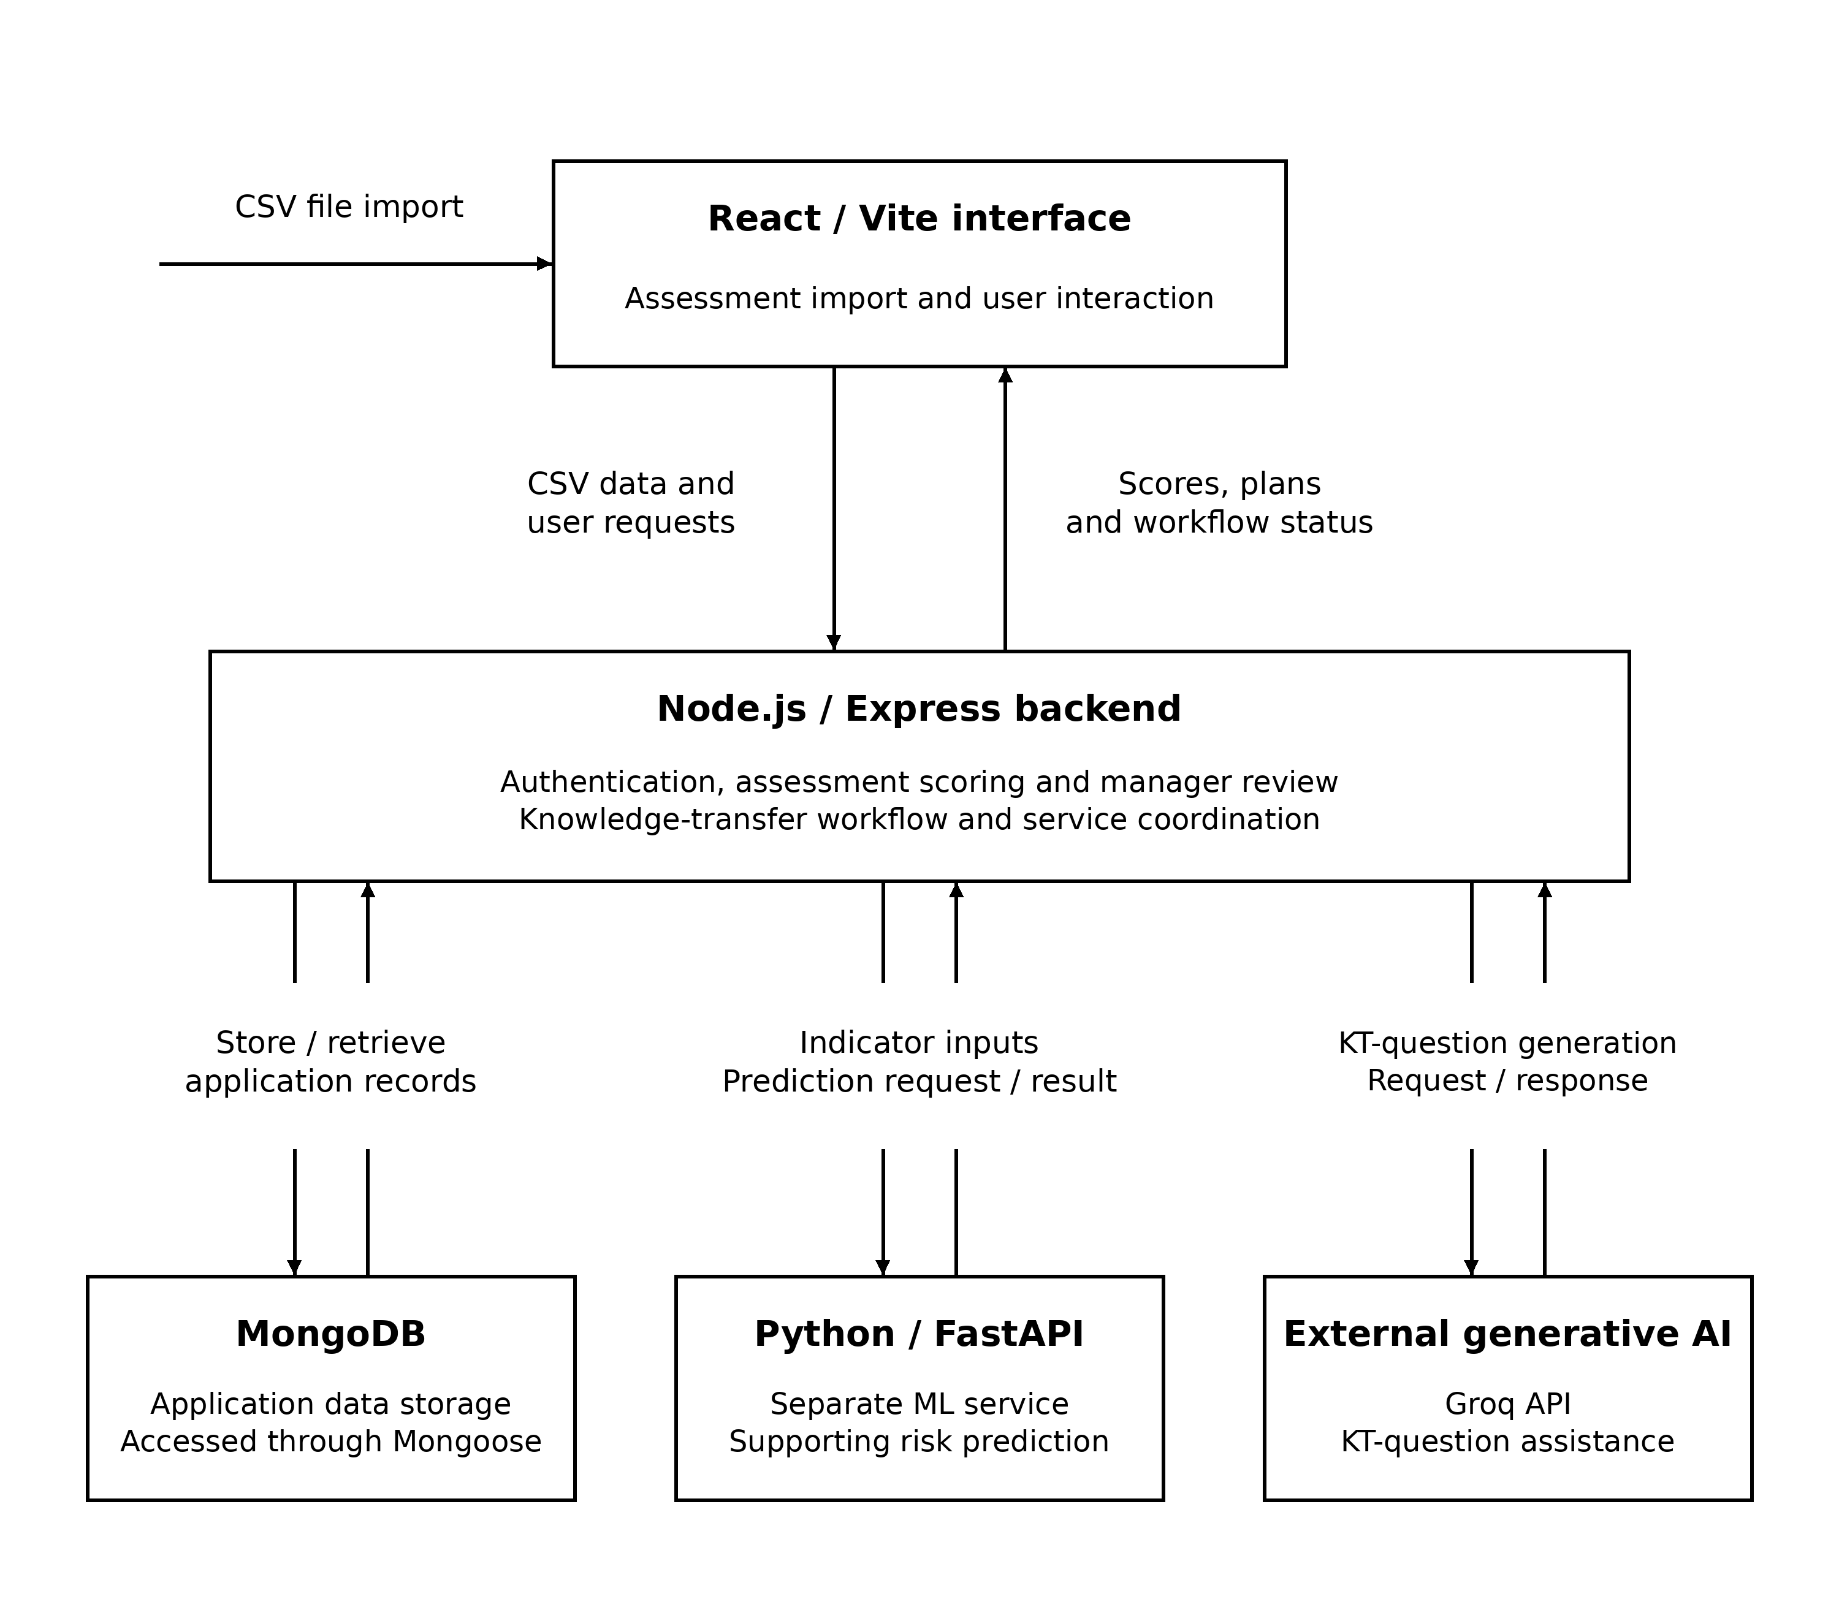Figure 4.1: KnowledgeGuard architecture and principal data flows.
Figure 4.2 shows the main records and their relationships. It is a conceptual class and data-model diagram, not a claim that every connection is implemented as a relational database foreign key. Manager validation is associated with the assessment; task records retain the evidence and confirmation states associated with a KT plan.
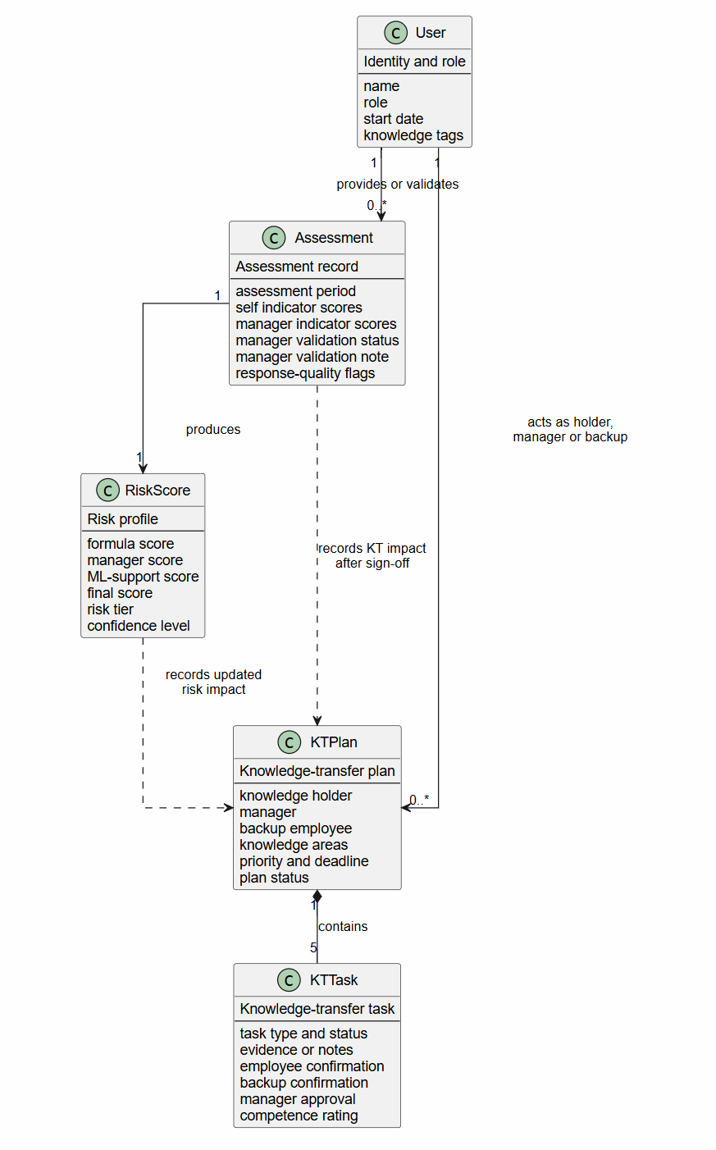
Figure 4.2: Class diagram and principal data relationships in KnowledgeGuard.
The use-case diagram identifies five actors: Employee, Manager, Backup Employee, HR User, and Administrator. It concentrates on actions available to those roles rather than internal services.
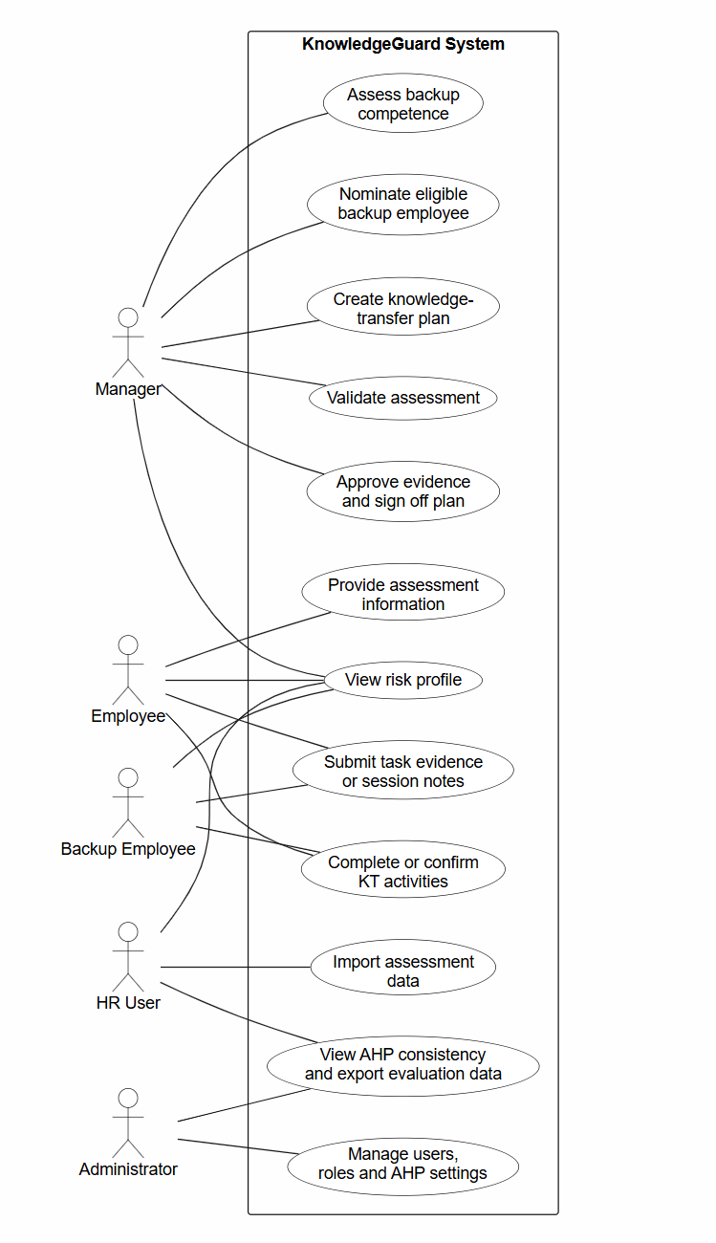
Figure 4.3: Use-case diagram for role-based KnowledgeGuard interactions.
The activity diagram presents the order of assessment, preliminary scoring, manager review, KT planning, task completion, sign-off, and separately imported reassessment. Its decision points separate an unvalidated preliminary profile from a validated final profile.
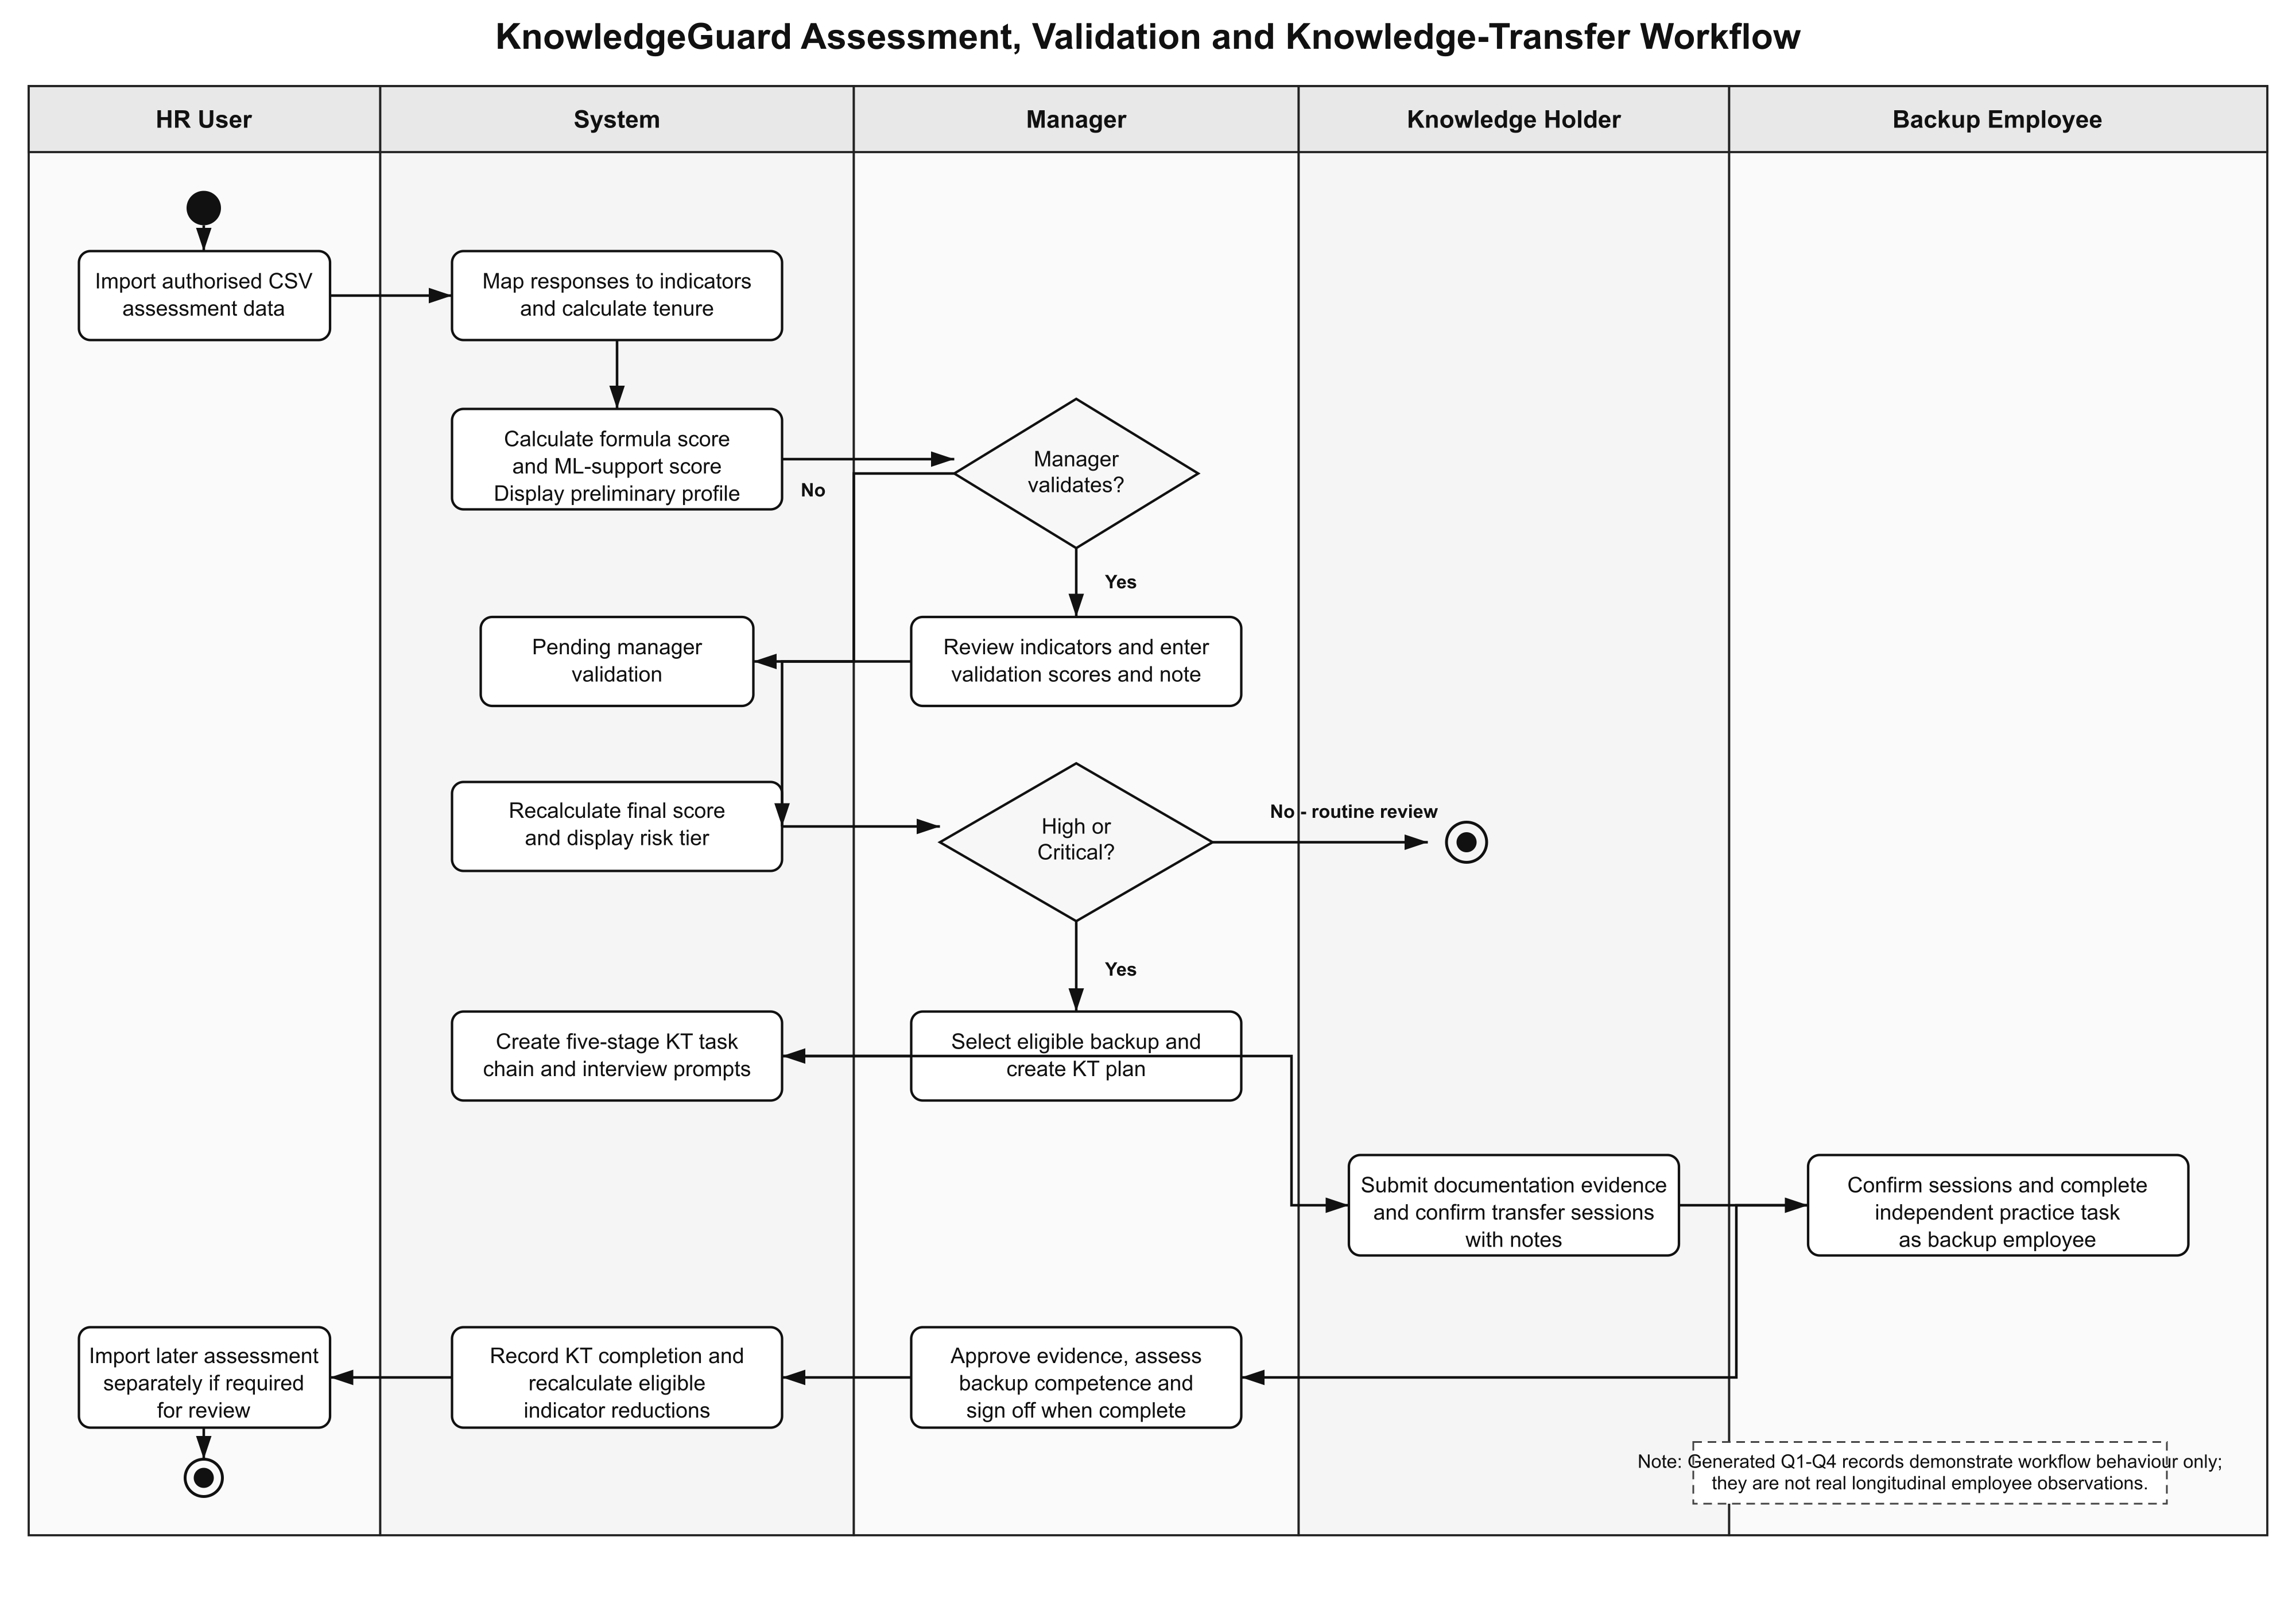
Figure 4.4: Activity diagram for assessment, validation and knowledge transfer.

4.4.2 From assessment response to indicator score
The importer maps recognized questionnaire answers to numerical exposure values. Higher values indicate more reported exposure. Questions are grouped into expertise uniqueness (EU), documentation gap (DG), project criticality (PC), and collaboration dependency (CD). Tenure (T) is calculated from the stored start date rather than an assessment answer. The questionnaire-to-indicator mapping is supplied in Appendix A.
The retained real Q1 workbook cannot be treated as a directly compatible import file. It uses shortened question headings, lacks the email field required by the importer, and includes synthetic risk columns that are excluded from the analysis. The current parser recognizes particular question-text fragments; some revised headings and the reverse-worded Agree and Disagree options need explicit mapping. Unrecognized input may receive a default value rather than rejection. Consequently, the manual reconstruction in Chapter 5 is distinct from verified parser output. Before a system-level import, create a documented, de-identified test copy with compatible headers and complete answer mappings, then reconcile the saved indicators with the source answers. Do not invent participant email addresses or overwrite the raw workbook.
Table 4.4: KnowledgeGuard indicators and predefined baseline weights
Indicator | Meaning in the prototype | Input | Baseline weight
EU | Few alternative holders can perform specialist work | Mapped assessment answers | 0.25
DG | Essential knowledge is insufficiently documented or accessible | Mapped assessment answers | 0.20
PC | Loss would affect important project or operational work | Mapped assessment answers | 0.20
CD | Other work strongly depends on this employee | Mapped assessment answers | 0.20
T | Service length, used as contextual information | Recorded start date | 0.15

The baseline formula is:
$$F=0.25(EU)+0.20(DG)+0.20(PC)+0.20(CD)+0.15(T)$$
The weights sum to 1.00 and are researcher-defined prototype settings rather than estimated effects or universally validated values. The literature supports examining concentrated expertise, documented knowledge and transfer dependencies [1], [2], [3]; it does not establish the numerical weights used here. Expertise uniqueness received the largest initial share as a design choice. Documentation gap, project criticality and collaboration dependency were assigned equal shares because this study had no empirical basis for a more precise ordering. Tenure supplies context, not proof of unique knowledge. AHP was used to explore expert preferences without retrospectively changing the formula used in the evaluated scenarios.
The system maps different Q1–Q4 question sets to the same four questionnaire-derived categories. Q1 concerns routine work; later generated quarters use absence, technical-change, and transfer-readiness contexts. This permits repeated prototype assessment while varying the question wording. The generated data do not establish that the four instruments have equivalent measurement properties in a real organization.
Q1 pairs questions 1 and 2 with reverse item 9 for EU, questions 3 and 4 with reverse item 10 for DG, questions 5 and 6 for PC, and questions 7 and 8 for CD. Direct three-option responses use exposure values 2, 6 and 10; the manual reverse-item reconstruction uses 2, 4, 6, 8 and 10 from Strongly agree to Strongly disagree. These intended mappings require an importer compatibility check before they can be described as deployed-system results. Appendix A retains the quarter-wise items, while Appendix D retains the participant information and consent wording.
Response-quality checks identify patterns that warrant review. The parser examines mapped-score variation and direct versus reverse-worded answers. Its low-variation check is not applied when fewer than four mapped responses are available; a standard deviation below 1.0 can trigger a warning. Such a flag may lower the displayed confidence level, but it is not a finding that a participant lied. The confidence discount is not directly subtracted from the numerical final risk score.
KnowledgeGuard also accepts ten pairwise comparisons for exploratory AHP calibration [20]. For raw form responses, its importer translates the form’s 1-left, 5-equal, 9-right scale into reciprocal ratios. It aggregates each comparison using the geometric mean, builds a reciprocal five-indicator matrix, derives proposed weights, and calculates a consistency ratio (CR). With five indicators, the consistency index is CI = (λmax − 5) / 4, and CR = CI / 1.12. The interface allows a proposed matrix to be applied only when CR < 0.10; the backend recalculates consistency and rejects a matrix at or above 0.10. A consistent result is a coherent set of comparisons, not evidence that its weights predict actual organizational loss. No AHP proposal was applied to the baseline scoring configuration used for the reported evaluation.

4.4.3 Formula, manager and machine-learning scores
The formula score F is calculated from the employee-derived indicators. If a manager validates alternative indicator values, the same weighted formula produces a manager score M. The FastAPI service provides a supporting ML score L. The three values remain visible so that a final tier is not presented as an unexplained model output.

Table 4.5: Supporting machine-learning design
Element | Implemented approach | Interpretation
Model | Random Forest classifier with 100 trees, maximum depth 6, minimum split 5, balanced classes, and fixed seed 42 [21] | Supporting classification, not an autonomous decision
Features | EU, DG, PC, CD, and T | Same five inputs available to the transparent formula
Default labels | Formula-derived tiers for 500 synthetic profiles | The model learns the configured rule, not observed departure outcomes
Supporting score | Class probabilities combined with fixed tier midpoint values | Continuous score L for the final blend
Alternative training route | Usable manager-validated records from at least two tiers, subject to the route’s minimum-record rule | Technical capability; not the training basis of the saved model evaluated here
Unavailable service | Formula score substitutes for L | Assessment can continue without ML inference

Before manager validation, the application calculates the preliminary final score as R = 0.70F + 0.30L. After validation, it calculates R = 0.30F + 0.50M + 0.20L. When the ML request fails, F substitutes for L. Scores are rounded to two decimal places before the configured tier is displayed. An unvalidated interface value of zero for the manager component is not included as a manager contribution to the preliminary blend.
The implementation classifies rounded final scores as Low at or below 5.00, Medium above 5.00 through 7.50, High above 7.50 through 9.00, and Critical above 9.00. Boundary checks should cover the exact thresholds and the next representable two-decimal value. Appendix H provides short implementation extracts; the executable logic, rather than an outdated source-file comment, defines the reported blend.
Table 4.6: Configured operational risk tiers
Tier | Final-score interval | Intended interpretation
Low | R ≤ 5.0 | Record and review as needed
Medium | 5.0 < R ≤ 7.5 | Examine exposure and supporting information
High | 7.5 < R ≤ 9.0 | Eligible holder for KT planning
Critical | R > 9.0 | Eligible holder for KT planning
The saved default model was trained on synthetic profiles whose labels came from the baseline formula. The application can also retrain using manager-validated assessment records, but that route was not used to produce the saved model reported in Chapter 5. Such manager-derived labels would still represent assessment judgements rather than observed continuity outcomes.
The ML service additionally provides Isolation Forest analysis for a supplied score history with at least three points [22]. It identifies an unusual value relative to that series; it cannot establish why the change occurred. This history check is distinct from the questionnaire response-quality checks and cannot determine whether a respondent was dishonest.
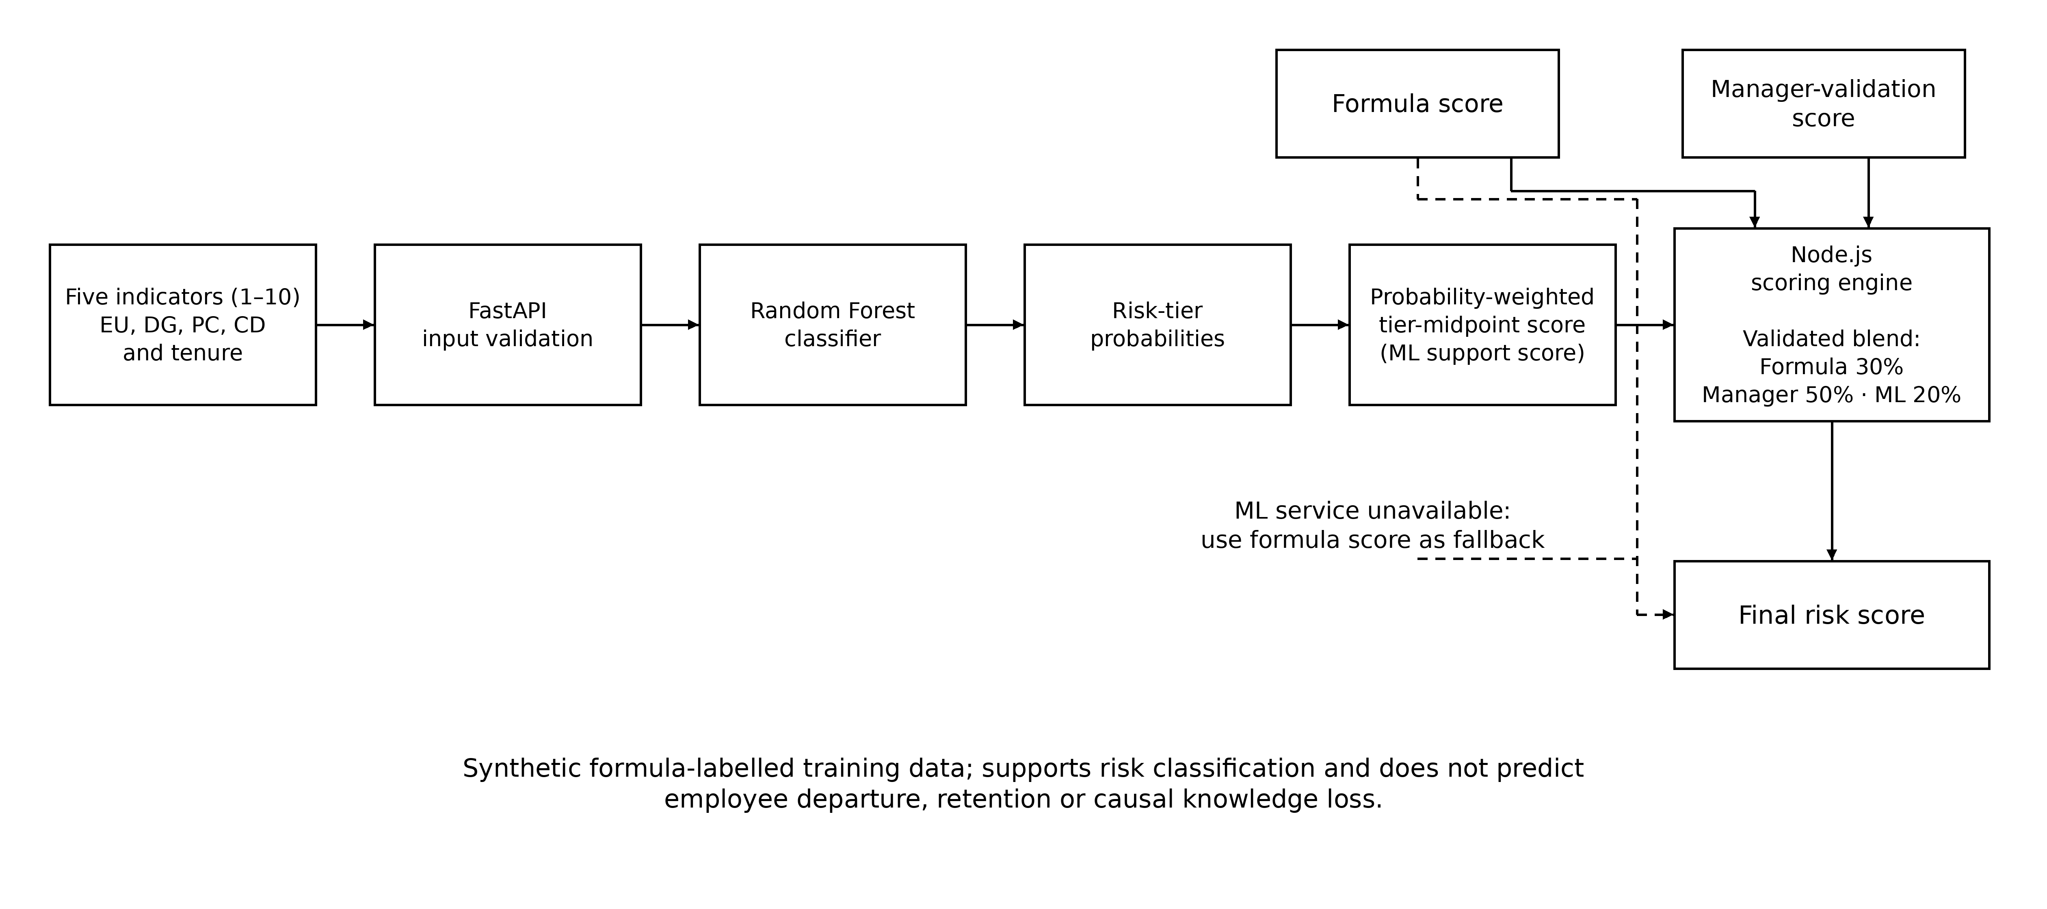Figure 4.5: Supporting machine-learning score process in KnowledgeGuard.

Figure 4.6 traces assessment import, response mapping, formula calculation, the ML request or fallback, storage of the preliminary profile, and later manager validation. It separates the preliminary and validated calculations.

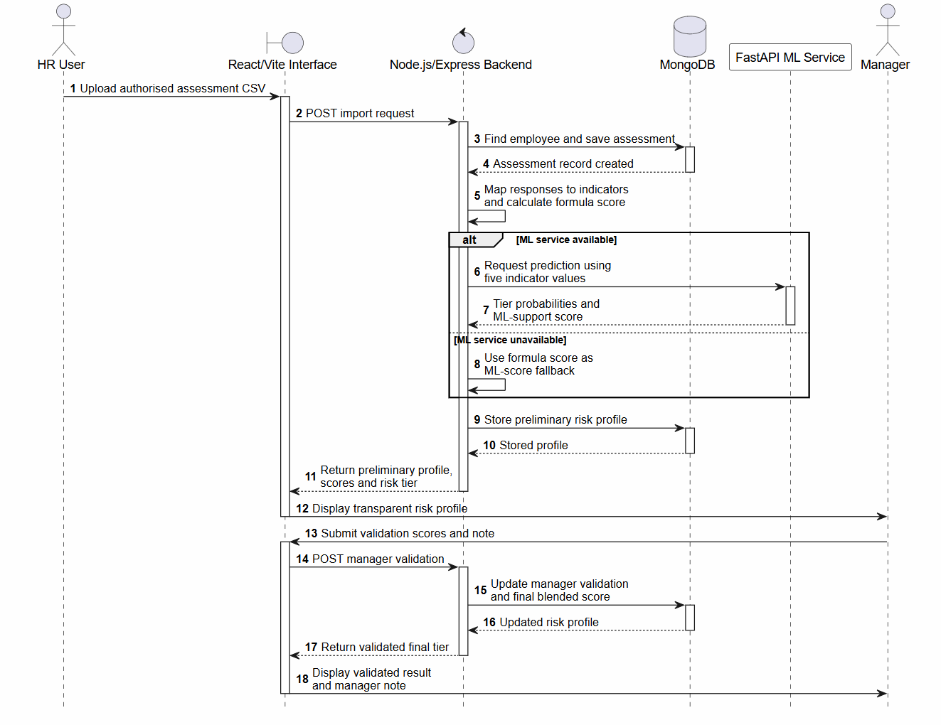
Figure 4.6: Sequence diagram for risk assessment and manager validation.

4.4.4 From risk review to knowledge transfer
A manager may create a KT plan when the knowledge holder’s latest risk tier is High or Critical. The plan records the knowledge holder, backup, knowledge areas, priority, and deadline. Knowledge tags suggest relevant areas and help rank backup candidates, but tag overlap is guidance rather than proof of competence. The backend rejects the same person as both holder and backup, checks team and role restrictions, and rejects a backup whose latest recorded tier is High or Critical. A person without a risk score is not automatically treated as high risk; this limits the safeguard.
A plan creates five task types: documentation, shadowing, structured interview, independent backup practice with competence review, and manager sign-off. AI may propose interview questions; predefined questions are used if that service is unavailable. The knowledge holder and backup submit evidence and confirm relevant sessions. The manager approves evidence and rates whether the backup can perform the work. The sign-off route checks preceding task completion before closure. These records demonstrate completion of the configured procedure, not lasting knowledge retention.
Completion is task-specific. Documentation requires manager approval. Shadowing and interview tasks require holder confirmation, backup confirmation and manager approval. Competence review is complete only for fully competent or minor-gap ratings. Manager sign-off requires the preceding tasks to be complete. These stored completion conditions should be tested separately from the existence of five task cards, because a pending plan does not demonstrate successful transfer.
When a plan is validly signed off, the application applies rule-based reductions to indicators that the approved activities could reasonably mitigate. Documentation Gap can decrease by up to 3 points when documentation evidence is approved. Expertise Uniqueness can decrease by up to 3 according to the backup competence rating. Collaboration Dependency can decrease by up to 2 when shadowing and interview evidence are approved and competence is recorded. Values cannot fall below 1. Project Criticality and Tenure remain unchanged. Under the baseline weights, the maximum formula-component reduction before scale bounds is 0.20(3) + 0.25(3) + 0.20(2) = 1.75. The final blended score may change by a different amount because its manager and ML components are recalculated.
This update represents the system’s configured interpretation of completed evidence. It is not a measured reduction in actual organizational knowledge loss. Sign-off also does not create a new quarterly assessment; a later history observation requires a separate import.
A manager-facing chat assistant can summarize the manager’s current team information and propose a validation change or KT action. The interface requires explicit confirmation before the proposed action is submitted, and backend role and workflow rules still apply. In-app alerts support assessment and KT follow-up. Email templates can provide reminders when credentials are configured, but this study did not measure email-delivery reliability. These supporting features were not separately evaluated as outcomes in the SUS/TAM questionnaire.
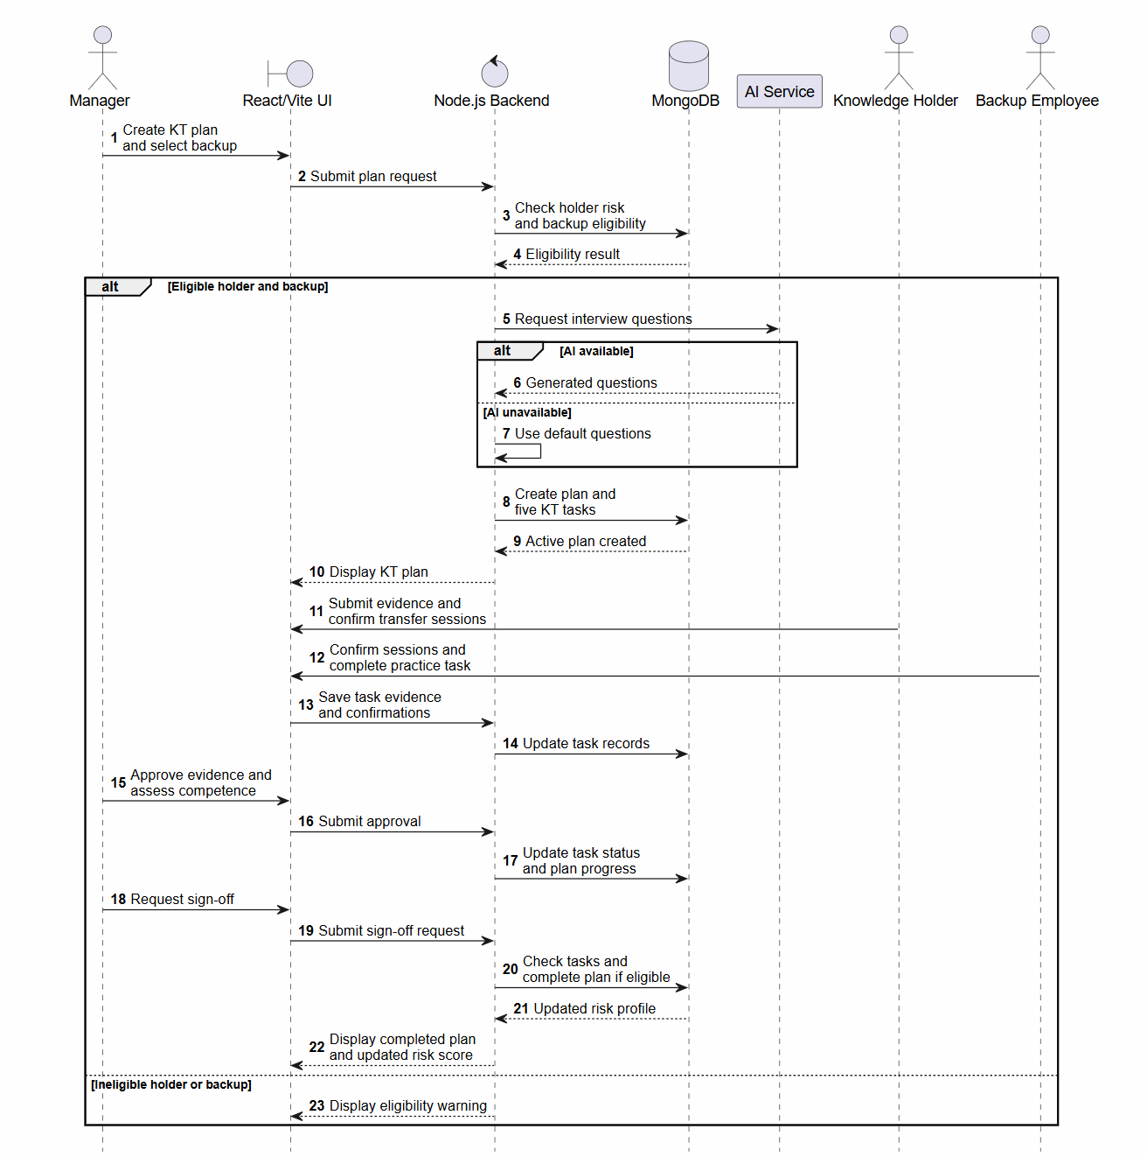
Figure 4.7: Sequence diagram for knowledge-transfer plan completion and sign-off.

4.5 Development and implementation procedure
Development began with questionnaire import and mapping, followed by formula scoring and the risk-profile display. Manager validation was added to retain human judgement alongside the employee-derived score. A separate Python service supplied the supporting classifier and history-anomaly functions. The KT module then added holder and backup checks, five task types, evidence, participant confirmation, competence review, sign-off, and the configured score update. Manager assistance and notifications were added as supporting functions.
Google Forms supplied questionnaire collection, while KnowledgeGuard consumed exported CSV data. This kept the research instruments separate from the application workflow. Formula calculation and key business rules remained in Node.js/Express; the Python service supplied supporting analytical results. Generative AI proposed interview questions but did not supply the knowledge being transferred or certify backup competence. Those responsibilities remained with the participants and manager.

4.6 Evaluation procedure
Evaluation was organized around the four objectives in Chapter 2. For Objective 1, the collected standalone Q1 responses were used to inspect response mapping, indicator calculation, tenure scoring, and quality warnings. The ten expert pairwise responses were converted using the form’s stated left-to-right scale, aggregated, and assessed for group consistency. Their proposed weights were compared with the baseline but were not applied to the evaluated scores.
For Objective 2, the Chapter 3 literature review was used to justify the indicator definitions, transparent scoring, manager review, and transfer stages. Its outcome is a documented design rationale, not a numerical effectiveness result.
For Objective 3, controlled records and generated Q1–Q4 scenarios were used to examine scoring, manager validation, KT eligibility, task states, and history. Each functional check recorded an input or initial state, action, expected result, observed result, and evidence type. A screenshot demonstrates a visible state; source-code inspection establishes that a control exists in the supplied implementation; a unit test verifies the tested function. These are not interchangeable with an executed end-to-end test. Chapter 5 reports which checks were actually performed and which remain implementation evidence only.
For repeatable verification, use fictional accounts and a disposable test dataset, record the application version and environment, establish the initial tier and task states, perform one action, and compare the actual output with the expected result. Retain the screenshot or response log and inspect the saved record when the test changes state. Record Pass only when the defined comparison succeeds, Fail when it does not, and Not executed when no run is retained. A repaired failure must preserve the original failure and a separate retest result. Appendix E contains one record table per functional case.
For Objective 4, ten evaluators used the deployed prototype independently. They were given the deployed-system link and questionnaire link through WhatsApp, then asked to log in, inspect the dashboard and a risk profile, review manager validation, review or create a KT plan, and inspect AHP validation before completing the form. The questionnaire provided ten System Usability Scale items [24] and separate acceptance items related to perceived usefulness, perceived ease of use, and behavioural intention [25].
For each SUS response, an odd-numbered item contributes its rating minus 1, while an even-numbered item contributes 5 minus its rating. The sum is multiplied by 2.5 to obtain an individual score from 0 to 100. The study reports the mean and sample standard deviation of the ten scores. Acceptance constructs are summarized separately using their item means on the five-point response scale. Because evaluation involved a small convenience group, these are descriptive findings rather than population estimates or evidence of organizational adoption.
[PLACEHOLDER M01: Add the actual evaluation date range, deployed build/version, browser/device details, and retained evaluator task-completion record if available. Do not infer roles, completion rates or timing from SUS/TAM responses.]
Table 4.7: Evaluation measures and required evidence
Aspect | Method | Evidence reported in Chapter 5
Assessment | Map Q1 responses and inspect calculated indicators, tenure, and warnings | De-identified processing and score evidence
AHP | Convert ten expert comparisons, compute group CR and weights; test an inconsistent control matrix separately | Aggregated matrix, proposed weights, consistency result, and safeguard evidence
Functional workflow | Run controlled actions and distinguish execution from code inspection | Test IDs, expected and observed results, and evidence type
KT change | Trace a generated case through approved tasks and sign-off | Task states and configured score update, labelled as a simulation
Usability | Score ten SUS forms | Mean, sample SD, range, and n = 10
Acceptance | Calculate construct means from the ten evaluation forms | Usefulness, ease-of-use, and intention summaries with n = 10
ML support | Inspect saved metrics and model configuration | Results interpreted only against synthetic formula-derived labels

Table 4.8: Generated quarterly questionnaire design
Quarter | Assessment context | Common mapping
Q1 | Routine work and day-to-day dependency | Ten questions mapped to EU, DG, PC, and CD
Q2 | Absence, incidents, and service continuity | Same four categories and scoring direction
Q3 | Architecture, technical change, and release risk | Same four categories and scoring direction
Q4 | Handover and cross-training readiness | Same four categories and scoring direction

The generated quarterly records test whether the application can maintain separate assessment periods for the same fictional identity. They are not a four-quarter sample of the colleagues who provided standalone Q1 responses. A score change following KT sign-off is also separate from a later imported assessment.

4.7 Ethics and project management
Questionnaire findings are reported in aggregate and fictional identities are used in workflow demonstrations. The real Q1 form included explicit voluntary consent and a data-use acknowledgement; all 30 retained responses contain these confirmations. Start dates were used to reproduce tenure scoring and must remain access-restricted because they can contribute to re-identification. The participant information and consent wording are retained in Appendix D. No separate ethics committee approval is claimed, and the study is not a partner-organization field trial. Raw research records should follow the retention arrangements stated to participants.
Risk tiers are intended to prioritize continuity preparation and managerial review, not to make employment decisions. Before use with organizational employee records, the collection purpose, lawful or approved basis, data minimization, access permissions, retention period, and external AI or email data flows would require organizational review. No penetration test or organizational privacy audit was completed for this prototype.
Development was organized iteratively using an Agile-Kanban-style workflow to track implementation and refinement. This was a project-management practice, not a controlled experiment or a separate source of effectiveness evidence.

4.8 Chapter summary
This chapter explained how KnowledgeGuard was designed, built, and evaluated. It separated collected colleague assessments, generated quarterly scenarios, expert comparisons, system-evaluation responses, and synthetic ML training data. It defined the baseline indicators and formula, the supporting ML and manager components, the KT workflow, and the methods used to check them. Chapter 5 reports the resulting artefact outputs, functional evidence, AHP comparison, and evaluator responses.

5. RESULTS

5.1 Chapter overview
This chapter reports the outputs of the KnowledgeGuard prototype and the available evaluation evidence. It presents assessment and knowledge-transfer results, functional verification, expert AHP comparisons, usability and acceptance responses, and the saved machine-learning results. Collected colleague responses, generated quarterly records, and synthetic ML training profiles are treated as separate evidence sources.

5.2 Evaluation data
Five sources contributed to the evaluation. Thirty colleagues employed in industry completed a standalone Q1 assessment and supplied a start date for the tenure calculation. A separate generated dataset contained 120 records for 30 fictional identities across Q1–Q4; it was used to demonstrate imports and score history. Ten expert responses supplied AHP pairwise comparisons. Ten evaluators used the deployed prototype and completed the SUS and TAM questions. The saved ML model was trained on 500 synthetic, formula-labelled profiles.
Table 5.1: Evaluation sources and their permitted interpretation
Source | Quantity | What it can demonstrate
Standalone colleague Q1 assessments | 30 responses | Questionnaire mapping and calculation using supplied start dates
Separate generated Q1–Q4 records | 120 records for 30 fictional identities | Repeated-import and history workflow
Expert pairwise-comparison forms | 10 responses | Exploratory group AHP weights and consistency
Deployed-prototype evaluation forms | 10 responses | Descriptive SUS and TAM results
Saved synthetic ML training record | 500 generated profiles | Internal performance against formula-derived labels

The colleague responses were not joined to the fictional quarterly identities. The generated records are not longitudinal observations of those colleagues.
The retained Q1 workbook contains 30 complete responses with consent and data-use acknowledgement. A manual reconstruction using the intended answer mapping produced mean indicator values of EU 6.53, DG 5.38, PC 4.47, CD 4.53 and T 2.00. Eleven records triggered reconstructed low-variation or contradiction warnings; these are review indicators, not findings of dishonest responding. Applying the saved model and preliminary formula/ML blend offline produced a mean score of 4.28, with 21 Low and 9 Medium classifications. Synthetic risk-score and category columns in the workbook were excluded. These findings are an exploratory offline reconstruction, not recorded deployed-parser output: the workbook lacks the required email field, its shortened headings differ from recognized importer text, and reverse-option compatibility remains unresolved. Tenure is time-dependent; the analysis used the 5 October 2026 reference date, not a historical quarter-end snapshot.
[PLACEHOLDER E01: Insert a verified import reconciliation for a de-identified, compatible test copy: run date/build, total submitted, accepted, rejected and flagged counts; record-level comparison of mapped indicators; screenshot or sanitized import log. Keep the manual results above labelled offline until this evidence exists.]

5.3 Prototype outputs and workflow demonstration

5.3.1 Assessment and manager validation
The risk profile presents the five indicator values, formula score, supporting ML score, final blended score, confidence information, and risk tier. Figures 5.1 and 5.2 show the same synthetic demonstration record before and after manager validation.
Before validation, the formula score was 9.7 and the ML support score was 6.2. The preliminary calculation was:
$$R=0.70(9.7)+0.30(6.2)=8.65$$

The interface displayed 8.7/10 and classified the case as High. Although the unvalidated manager field displayed 0.0, that value was not used in the preliminary calculation. After the manager submitted validated indicator values and a note, the manager score was 10.0. The calculation became:
$$R=0.30(9.7)+0.50(10.0)+0.20(6.2)=9.15$$

The interface displayed 9.2/10 and classified the case as Critical. The comparison demonstrates how recorded managerial review changes the decision-support result. The tier does not predict that the employee will leave.
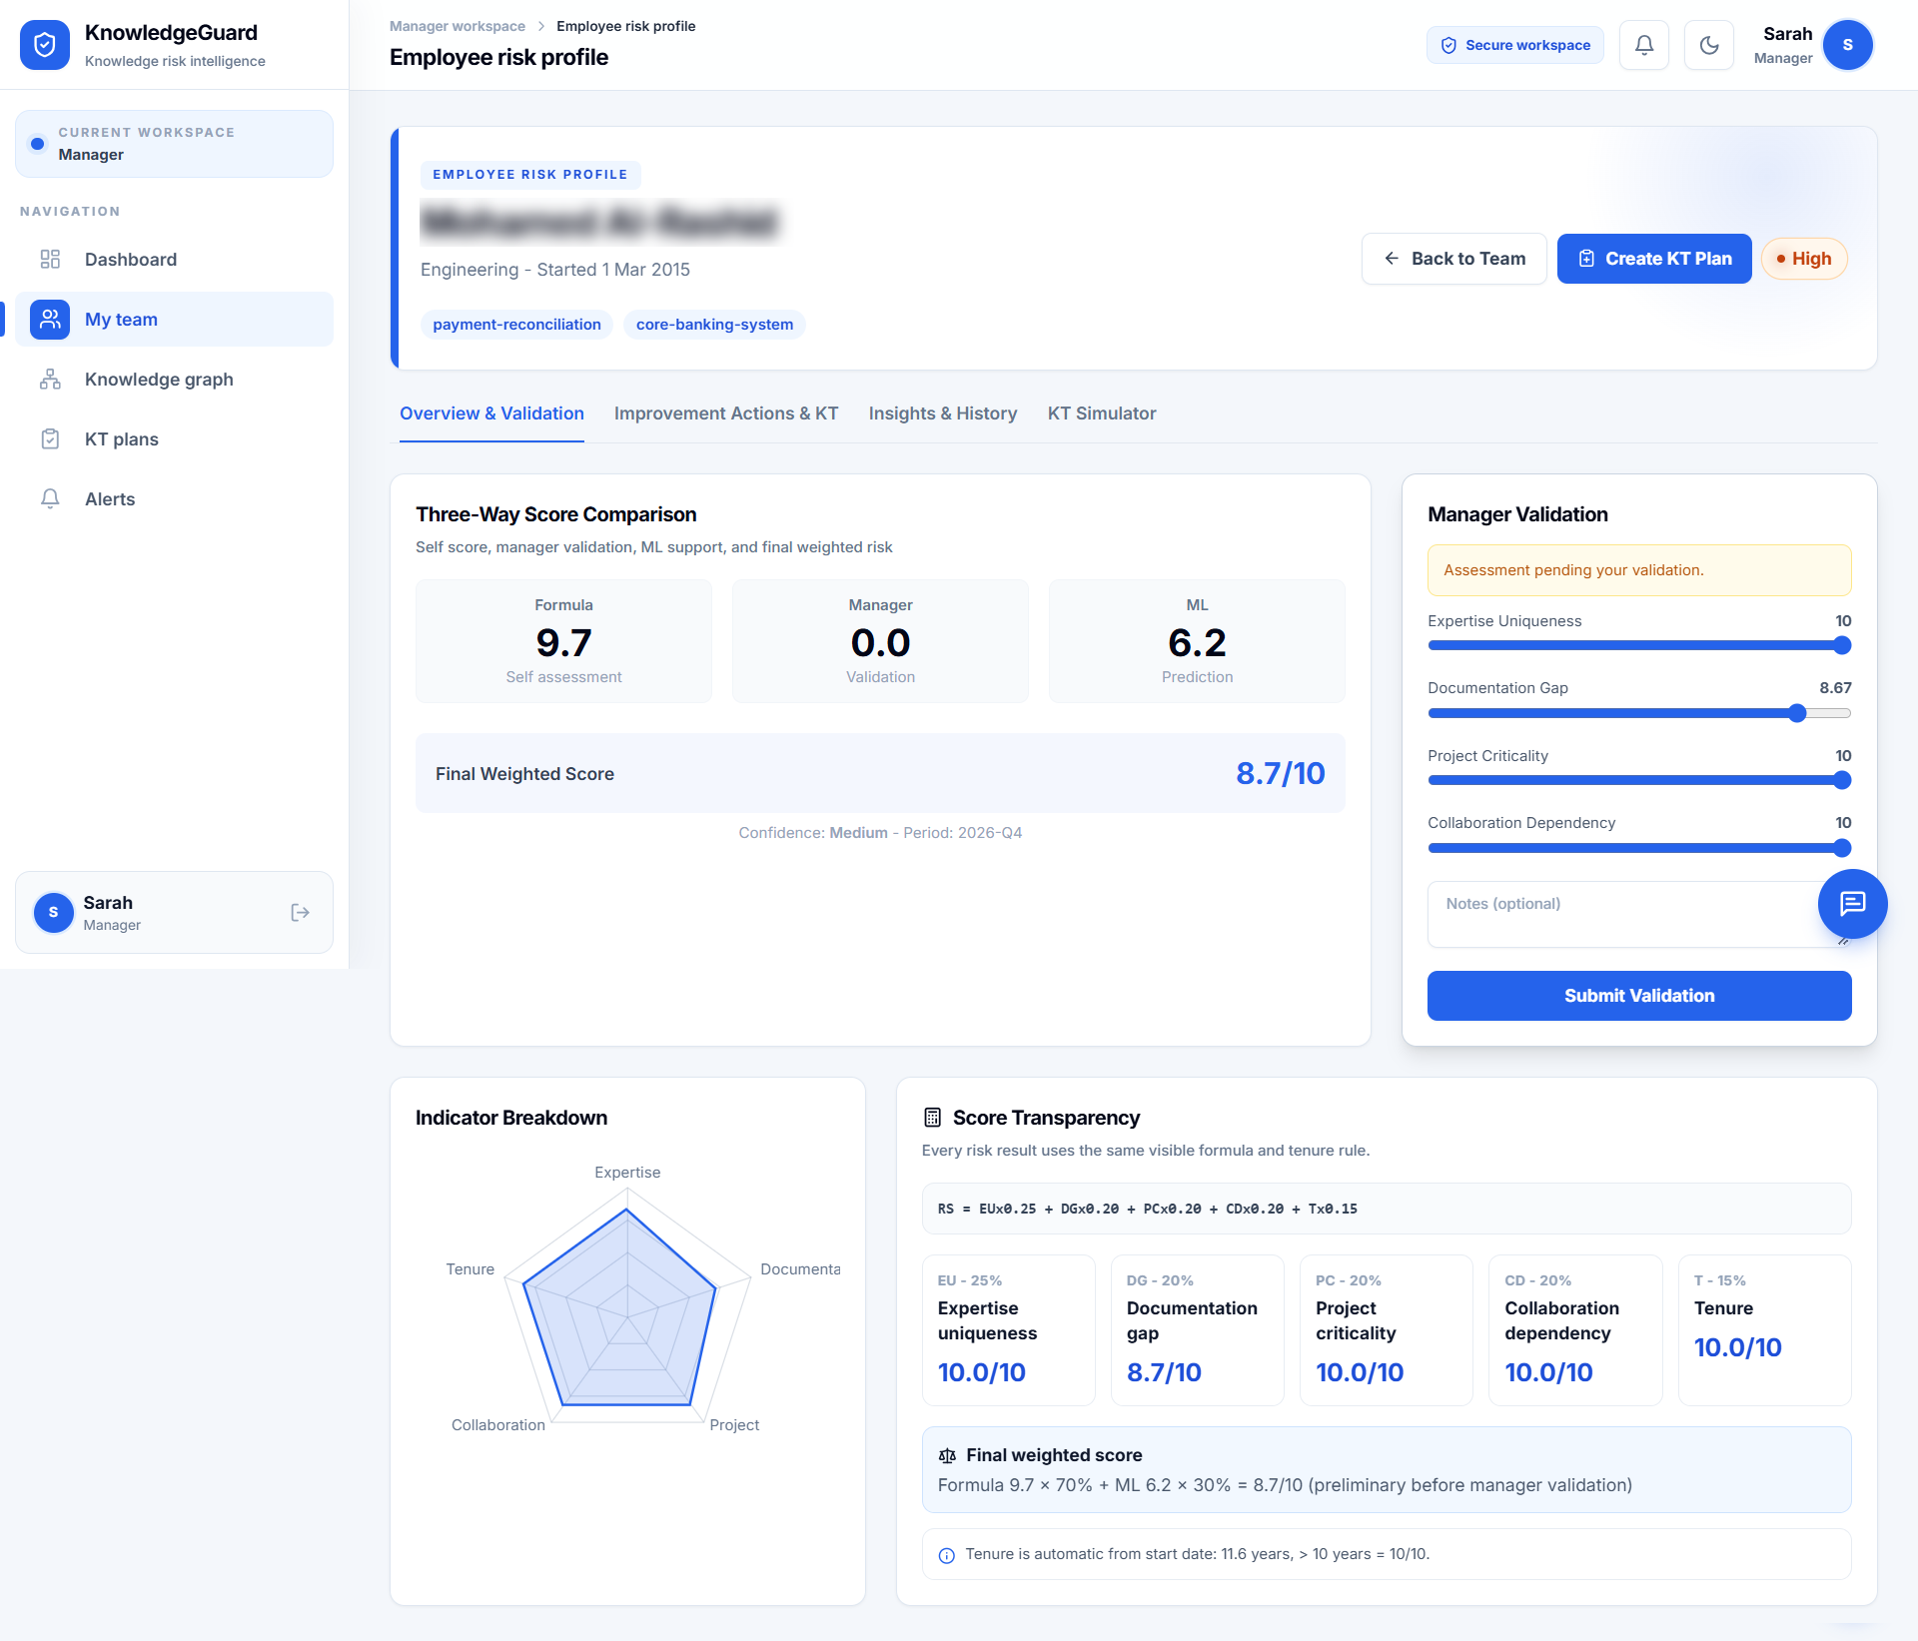
Figure 5.1: Preliminary risk profile for a synthetic demonstration record before manager validation.
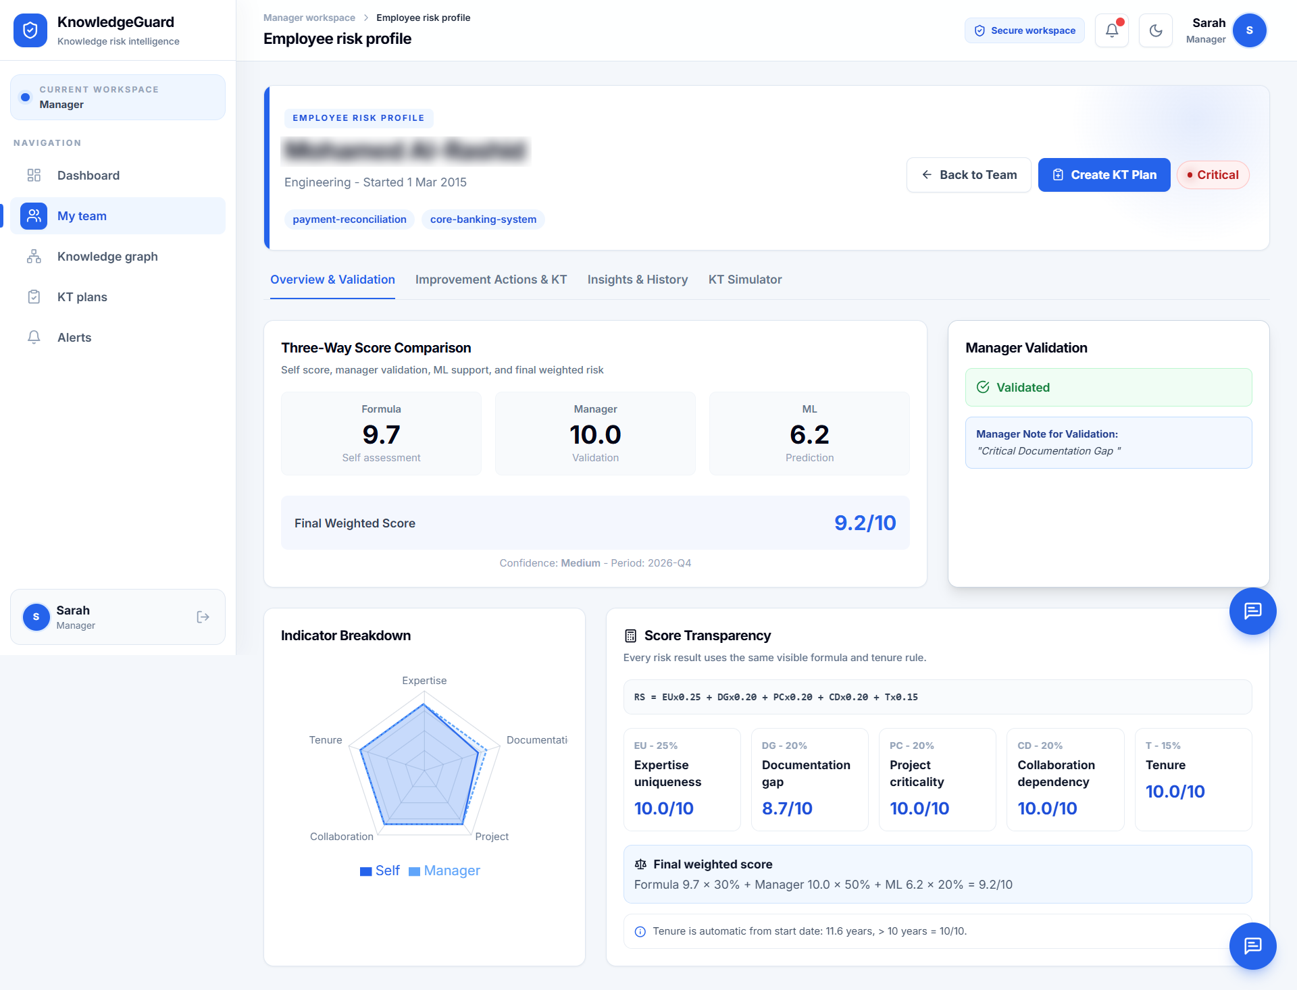Figure 5.2: The same synthetic risk profile after manager validation.

5.3.2 Knowledge-transfer planning and tasks
The plan-creation route identifies the knowledge holder, backup, knowledge areas, priority and deadline. Knowledge tags guide selection. Existing evidence shows an active plan and task sequence, but it does not establish that the creation request or an ineligible-backup rejection was executed successfully. Figure 5.3 is reserved for a creation-screen capture linked to a recorded test case.
[PLACEHOLDER E02: Insert an authentic KT creation screenshot showing a fictional eligible holder, distinct backup, transfer areas and deadline. Retain the creation response/plan ID in T08; record a separate rejected High/Critical backup attempt in T10. Remove identifying or confidential information.]
Figure 5.3: Knowledge-transfer plan creation for a fictional eligible holder and backup.
For an eligible plan, the prototype creates five task types: documentation, shadowing, structured interview, backup practice and competence review, and manager sign-off. Figure 5.4 shows an active plan with these tasks pending. It demonstrates task creation, not completed transfer or successful sign-off.

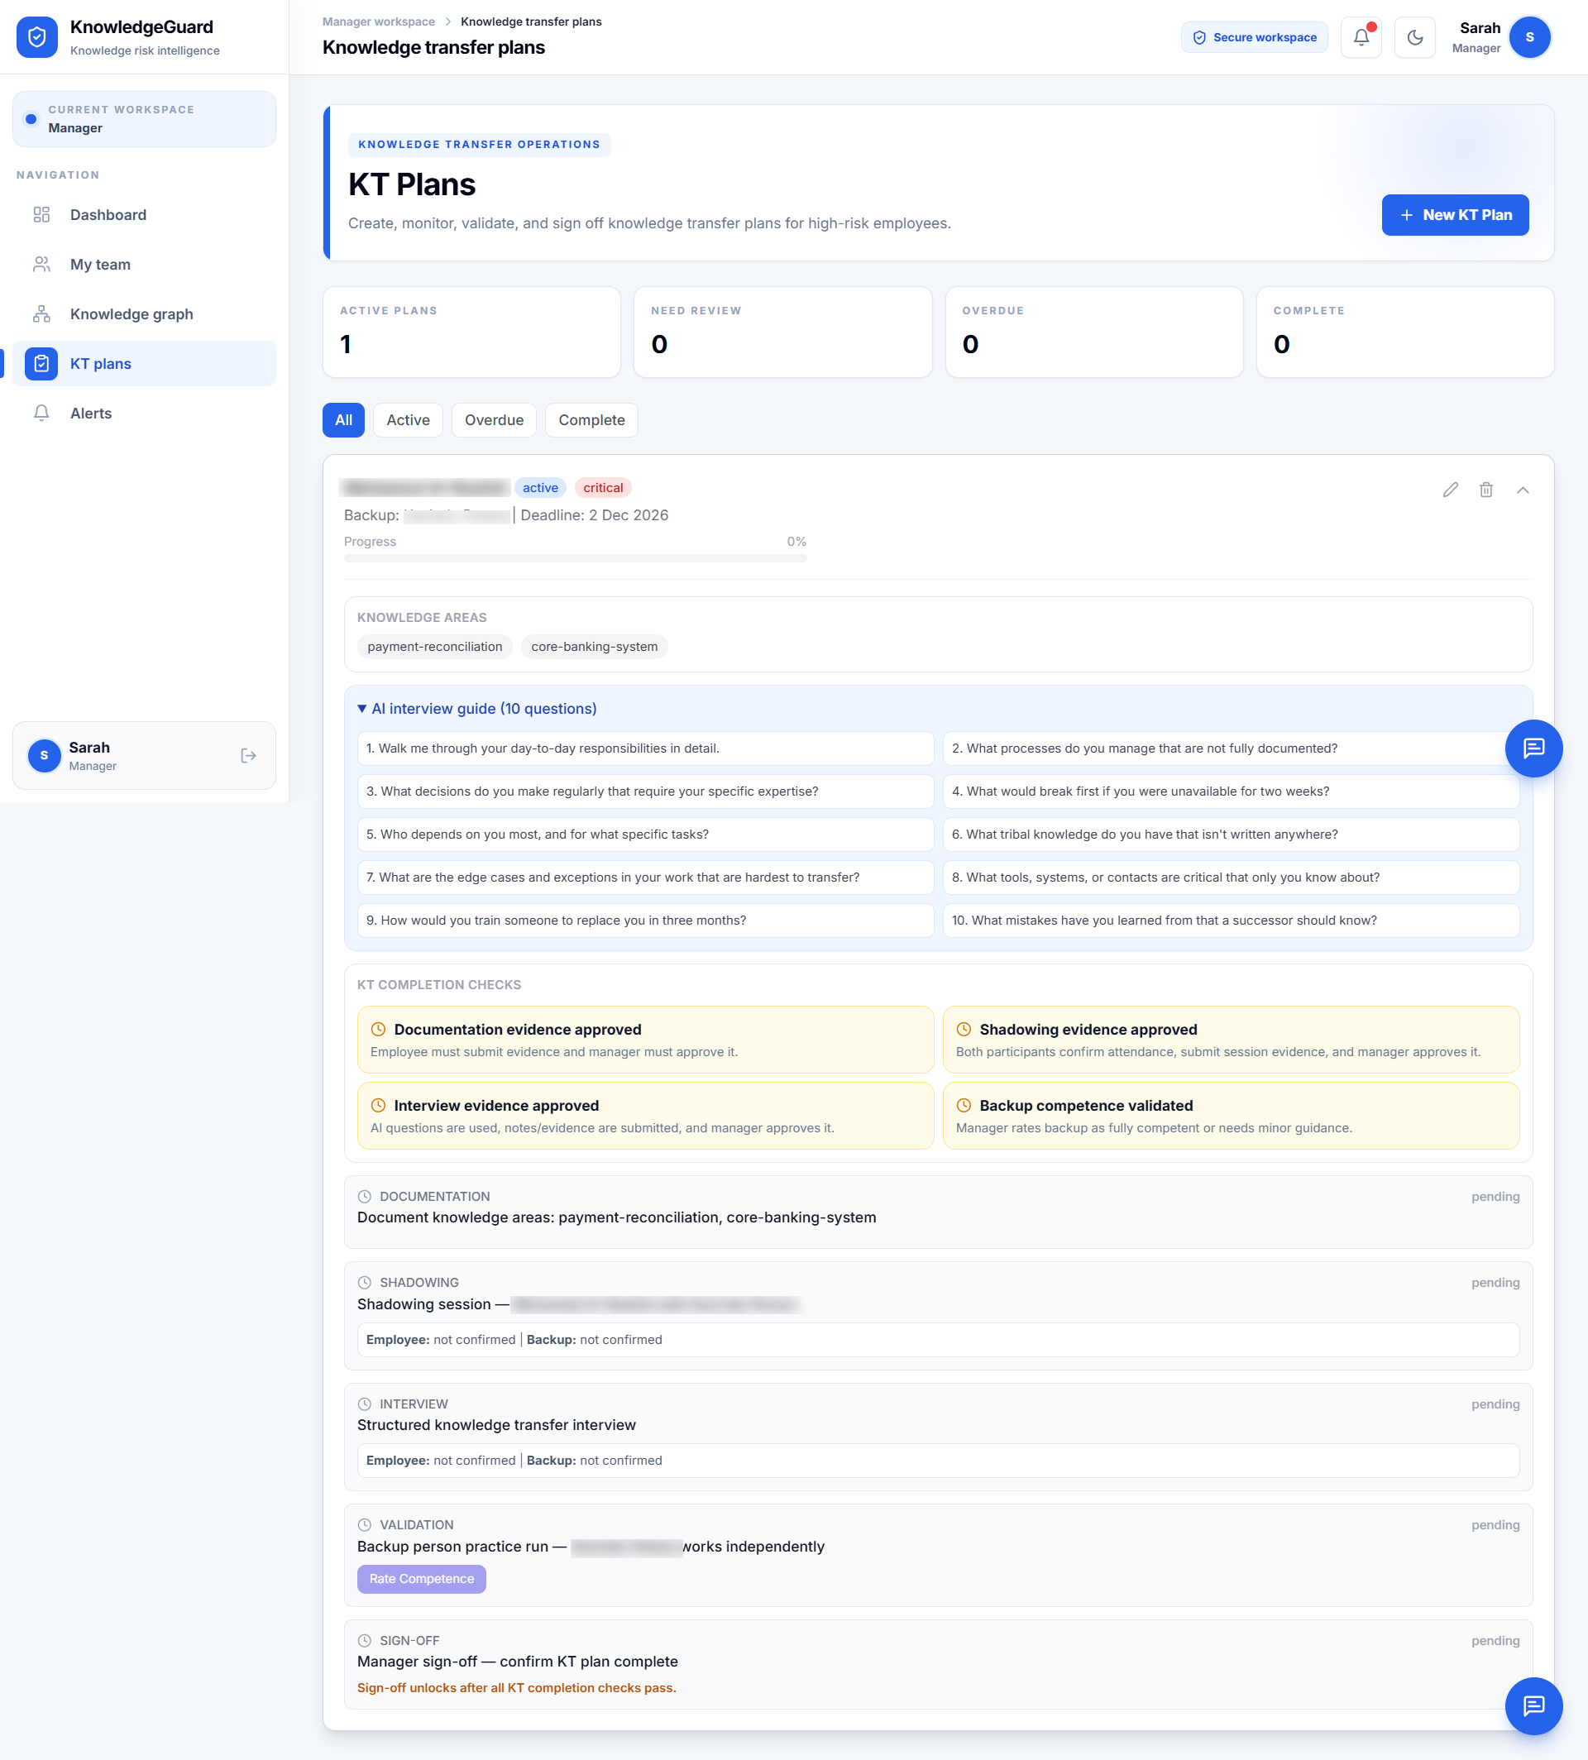
Figure 5.4: Five knowledge-transfer task types created for a synthetic demonstration plan.

5.3.3 Worked knowledge-transfer score trace
A separate arithmetic example illustrates the configured score update. It is not the employee shown in Figures 5.1 and 5.2. With EU = 9, DG = 8, PC = 9, CD = 7, and T = 10, the baseline formula produces:
$$F=0.25(9)+0.20(8)+0.20(9)+0.20(7)+0.15(10)=8.55$$
If the illustrative manager score is 8.50 and the assumed ML support score is 6.50, the validated blend is:
$$R=0.30(8.55)+0.50(8.50)+0.20(6.50)=8.115≈8.12$$

The assumed 6.50 is not a captured prediction for this example.
In a simulated completed plan, approved documentation lowers DG by 3; a fully competent backup rating lowers EU by 3; and approved shadowing and interview evidence lower CD by 2. PC and tenure remain unchanged. The updated indicator values are EU = 6, DG = 5, PC = 9, CD = 5, and T = 10, giving F = 6.80. The formula component therefore falls by 1.75 points under the configured rules. This is a rule-based system update, not a measured reduction in organizational knowledge loss. No post-sign-off final blended score is assumed because its manager and ML components must also be recalculated.
[PLACEHOLDER E03: Add a completed-plan evidence trace for T12/T13: blocked early sign-off, task approvals and confirmations, competence rating, accepted sign-off, and saved before/after indicators. Until then, Table 5.2 remains a simulated arithmetic example, not an executed mitigation result.]

Table 5.2: Simulated knowledge-transfer score trace
Stage | EU, DG, PC, CD, T | Formula score | Interpretation
Before KT | 9, 8, 9, 7, 10 | 8.55 | Illustrative blended score: 8.12
After stipulated approved tasks | 6, 5, 9, 5, 10 | 6.80 | Configured indicator update, not measured retention
Later quarter | Requires a separate generated assessment import | Calculated from that new record | Separate workflow-history event

5.4 Functional verification and implementation evidence
Table 5.3 separates captured interface states, executed utility tests, offline reconstruction and code inspection. The AHP suites were re-run locally on 5 October 2026: all three backend tests and five frontend CSV tests passed. They cover mathematical consistency, reciprocity, form conversion and CSV validation, not deployed API application, permissions or persistence. No overall functional pass rate is calculated because the remaining workflows lack complete execution records.
Table 5.3: Functional verification and implementation evidence
Test | Expected function | Evidence currently available | Verification status
FT01 | Map Q1 answers and calculate tenure | 30 responses manually reconstructed; mean offline score 4.28, 21 Low and 9 Medium. Actual importer compatibility unresolved. | Offline reconstruction only; live import/reconciliation pending
FT02 | Calculate preliminary score | Figure 5.1 shows formula 9.7, ML 6.2, final 8.7, and High tier | Visible interface result
FT03 | Record manager validation and recalculate | Figure 5.2 shows manager 10.0, note/status, final 9.2, and Critical tier | Visible interface result
FT04 | Reject inconsistent AHP input | 3 backend AHP and 5 frontend CSV utility tests passed locally on 5 October 2026; group capture CR 0.0822. | Utility tests passed; deployed API/settings persistence test pending
FT05 | Reject a Low/Medium KT holder | Backend checks the holder’s latest risk tier | Code inspection only; execution evidence pending
FT06 | Reject a High/Critical backup | Client guidance and backend latest-tier check are present | Code inspection only; execution evidence pending
FT07 | Create five KT task types | Figure 5.4 shows the five pending stages | Visible interface result
FT08 | Block early sign-off and permit valid sign-off | Prerequisite and mitigation rules identified in code | Code inspection only; execution evidence pending
FT09 | Continue assessment when ML is unavailable | Code substitutes the formula score for an unavailable ML result | Code inspection only; execution evidence pending
FT10 | Require confirmation for a manager chat action | Confirmation and backend checks identified in code | Code inspection only; execution evidence pending
FT11 | Support alerts and optional email | Alert and email paths identified in code | Code inspection only; execution evidence pending

The KT creation route checks whether the holder’s latest tier is High or Critical. It does not independently require a manager-validation flag before plan creation. Manager validation is therefore part of the intended decision process, but it should not be described as an enforced prerequisite.
The main findings requiring further verification are importer compatibility with the actual Q1 instrument, preservation of settings after an inconsistent AHP request, ineligible-holder and backup rejection, complete KT sign-off and persisted score updates, ML fallback, chat confirmation and access control. The evidence register in Appendix F links these gaps to specific test cases. A successful unit-test suite does not resolve an unexecuted workflow case.

5.5 AHP results
The ten expert forms used a scale in which 1 favoured the left indicator, 5 indicated equality, and 9 favoured the right indicator. Responses were converted to reciprocal pairwise ratios and aggregated using geometric means. The resulting group matrix gave λmax = 5.3682 and CR = 0.0822. As CR is below the configured 0.10 threshold, the aggregated group comparison met the consistency rule. This does not establish that each respondent was individually consistent or that the weights predict actual knowledge-loss outcomes.
Table 5.4: Predefined baseline and exploratory AHP group weights
Indicator | Baseline | Group AHP proposal | Difference
Expertise uniqueness | 25.00% | 51.77% | +26.77 percentage points
Documentation gap | 20.00% | 12.72% | −7.28 percentage points
Project criticality | 20.00% | 14.78% | −5.22 percentage points
Collaboration dependency | 20.00% | 15.05% | −4.95 percentage points
Tenure | 15.00% | 5.67% | −9.33 percentage points

The proposal places substantially more weight on expertise uniqueness than the predefined baseline. The AHP weights were not applied to the evaluated scoring scenarios. The baseline had been fixed before those demonstrations, and consistency of expert comparisons is not external validation against observed organizational outcomes. Changing weights after evaluation would also make the reported cases difficult to compare under one method. The difference is reported as an exploratory finding that warrants later sensitivity analysis and organizational review.
The real Q1 workbook is now available, but a comparison under the exploratory AHP weights has not been completed. A valid sensitivity analysis would hold the mapped inputs, tenure reference date and score-blending rules constant, change only the formula weights, and report score differences and tier transitions. It would demonstrate sensitivity to weighting choices, not establish that one weighting scheme is correct.
[PLACEHOLDER E04 OPTIONAL: Add baseline-versus-AHP sensitivity results for the same 30 reconstructed inputs, including weights, rounding, mean change and tier-transition counts. If not performed, retain the limitation and remove this placeholder before submission.]

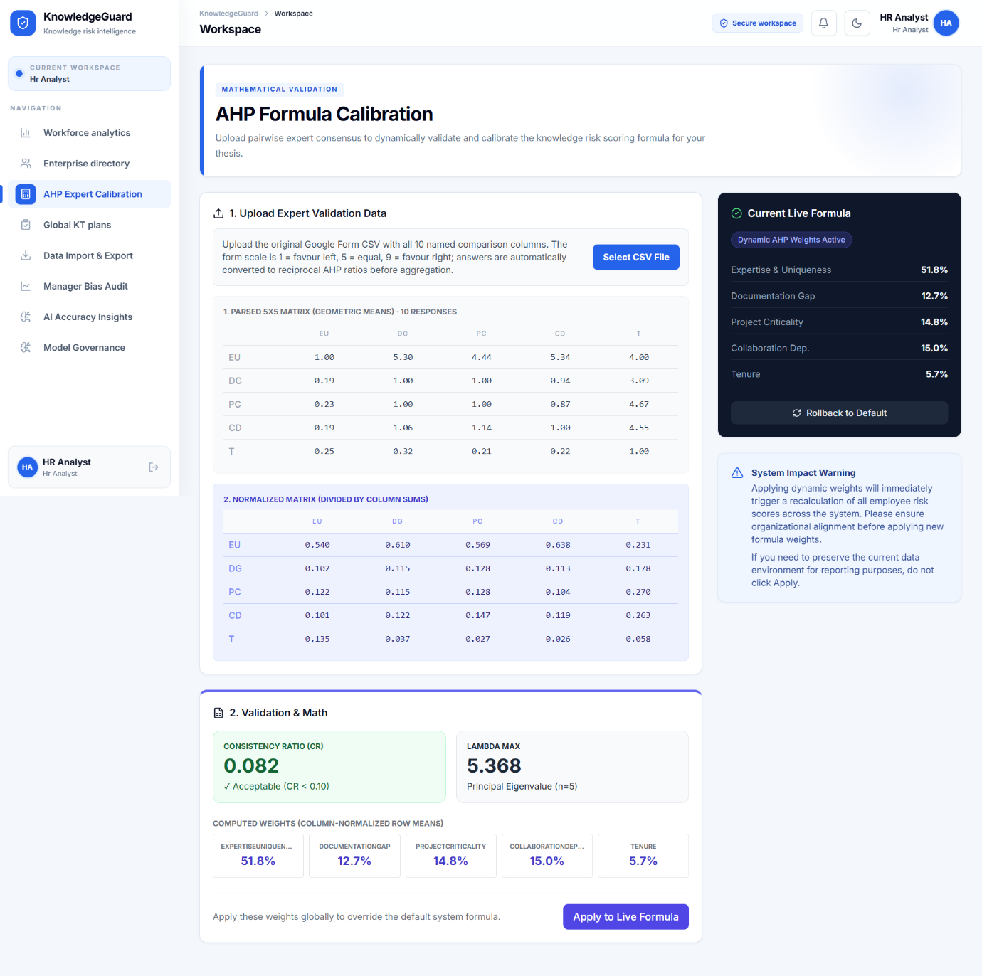
Figure 5.5: Consistent aggregated AHP group matrix with CR = 0.0822.

5.6 Generated quarterly score history
The separate generated Q1–Q4 records support demonstration of repeated assessment periods for fictional identities. They are not longitudinal records of the real Q1 respondents. A generated score change demonstrates system history, not measured employee change or causal KT effectiveness. A verified history capture and period-by-period reconciliation are still required to establish the displayed values against imported records.
[PLACEHOLDER E05: Insert the score-history screen for one fictional identity with Q1–Q4 period labels. Compare each displayed score/tier with its saved assessment and record the import dates. Clearly label the dataset as generated.]
Figure 5.6: Quarterly score history for a fictional identity using generated Q1–Q4 inputs.

5.7 Usability and acceptance results
Ten evaluators used the deployed prototype independently after receiving its link and the evaluation form through WhatsApp. They were asked to inspect the dashboard and a risk profile, review manager validation and KT planning, view AHP validation, and then answer the SUS and TAM questions. Their exact professional role counts and individual task completions were not recorded.
The ten SUS scores had a mean of 89.50, sample standard deviation of 3.07, and range of 85.0–95.0. These figures describe favourable perceived usability in this evaluator group; they are not a task-success rate.
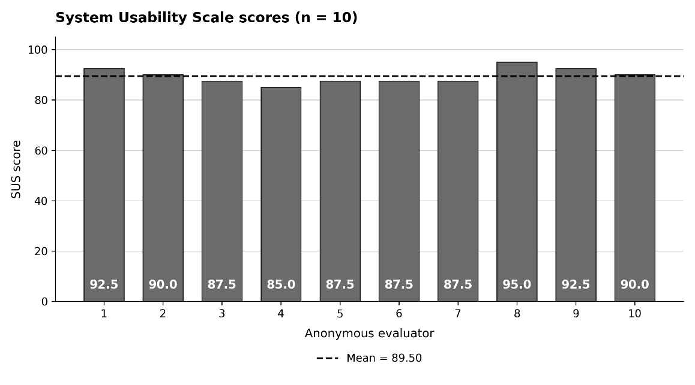
Figure 5.7: SUS results for the ten system evaluators.
The mean TAM ratings were 4.43/5 for perceived usefulness, 4.53/5 for perceived ease of use, and 4.60/5 for behavioural intention. Behavioural intention had the highest descriptive mean, although an intention rating does not establish subsequent adoption.

Table 5.5: System-evaluation questionnaire summaries
Measure | n | Result | What the result describes
SUS | 10 | Mean 89.50; sample SD 3.07; range 85.0–95.0 | Perceived usability in this evaluator group
Perceived usefulness | 10 | Mean 4.43/5 | Perceived value
Perceived ease of use | 10 | Mean 4.53/5 | Perceived ease
Behavioural intention | 10 | Mean 4.60/5 | Stated intention
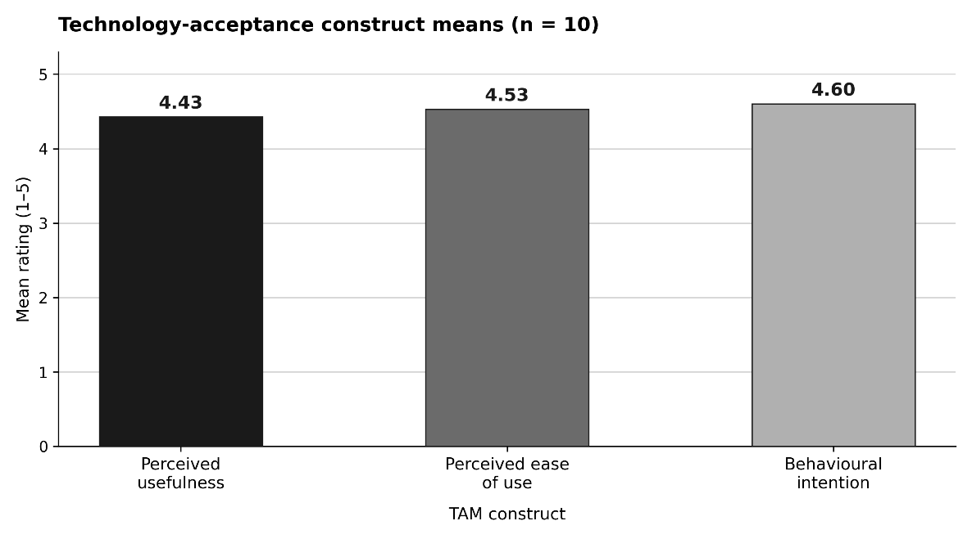
Figure 5.8: Mean TAM construct ratings from ten evaluators.

5.8 Supporting machine-learning results
The saved default model was trained on 500 synthetic profiles labelled from the baseline formula. Its saved training accuracy was 0.9780, weighted F1 was 0.9781, and mean five-fold stratified cross-validation F1 was 0.8526 with standard deviation 0.0487. Cross-validation better describes performance across the generated-data folds than training accuracy, but neither result measures prediction of real departures or knowledge retention.

Table 5.6: Saved ML metrics and interpretation
Saved measure | Value | Interpretation
Training accuracy | 0.9780 | Fit to synthetic, formula-derived labels
Weighted F1 | 0.9781 | Performance in the same synthetic-label setting
Cross-validation F1 | 0.8526 ± 0.0487 | Variation across generated-data folds
Represented classes | Low, Medium, High | No Critical examples in the saved model

The service converts class probabilities into an ML support score using fixed values: Low = 1.5, Medium = 4.3, High = 6.5, and Critical = 8.8. These conversion values are not the operational tier thresholds used for the final blended score. In particular, the value 6.5 assigned to the ML High class falls below the operational High threshold of 7.5. Because the saved model contains no Critical class, its ML score cannot exceed 6.5. This helps explain why a record with formula score 9.7 can receive ML support score 6.2. It also means the current ML component can dampen high-risk blended scores; that scale should be recalibrated in future evaluation.
The application provides a route to retrain using manager-validated assessment records from more than one tier. The reported saved model was not trained on those records. Manager-assigned labels would still require comparison with independently observed outcomes before predictive validity could be claimed.
The saved-model metrics demonstrate agreement with labels generated by the same baseline formula that supplies one component of the final score. This limits their independence as validation evidence. The absence of a Critical class and the lower support-score scale warrant calibration checks before operational use. Future evaluation should separate training and external validation data and use independently observed continuity or transfer outcomes; neither training accuracy nor evaluator approval substitutes for that evidence.

5.9 Results against the objectives
Table 5.7: Results against the Chapter 2 objectives
Objective | Result supported by the available evidence
O1 — Identify indicators and develop assessment with response-quality checking | Five indicators, tenure calculation and response-quality checks were implemented. Thirty real Q1 responses were reconstructed offline; actual importer mapping and a recorded import reconciliation remain outstanding.
O2 — Examine research and use it to inform the design | The literature review informed transparent scoring, manager involvement, backup practice, and staged knowledge transfer.
O3 — Build an integrated decision-support workflow | Assessment and validation states and creation of five KT task types are visible. Several safeguards still have inspection-only rather than execution evidence, as shown in Table 5.3.
O4 — Evaluate functionality, usability, and acceptance | Selected interface outputs and AHP utility tests were verified; ten evaluators provided favourable descriptive SUS and TAM responses. Several safeguards remain supported by implementation inspection rather than recorded deployment tests, as shown in Table 5.3.

5.10 Chapter summary
KnowledgeGuard provides an implemented assessment-to-transfer workflow with visible score components and managerial review. Captured profiles support the displayed preliminary and validated calculations, and a pending plan shows the five task types. Eight local AHP/CSV utility tests passed. The real Q1 findings remain a manual offline reconstruction pending importer reconciliation; remaining workflow controls require recorded execution. The consistent expert-group matrix offers exploratory alternative weights, while ten evaluators reported favourable perceived usability and acceptance. Synthetic ML performance and simulated mitigation changes do not demonstrate prediction of departures or prevention of organizational knowledge loss. Chapter 6 interprets these results within those limits.

6. DISCUSSION AND CONCLUSIONS

6.1 Chapter overview
This chapter interprets the KnowledgeGuard results against the research questions and the literature reviewed in Chapter 3. It identifies the study’s contribution, explains what the evaluation does and does not establish, and proposes the next steps needed to test the system in an organization.

6.2 Discussion of the research questions

6.2.1 RQ1: Operationalizing knowledge-loss risk
RQ1 asked how literature-informed indicators of employee-level knowledge-loss risk could be used in a structured prototype assessment. KnowledgeGuard operationalized five dimensions: expertise uniqueness, documentation gap, project criticality, collaboration dependency, and tenure. Questionnaire answers are mapped to the first four dimensions, while tenure is calculated from a recorded start date. The system displays the indicator values and checks selected response patterns for possible quality concerns.
This provides a repeatable way to identify why a case may need managerial attention. For example, a high documentation gap identifies a different potential problem from high project criticality. A response-quality warning prompts review; it does not establish that an employee answered dishonestly.
The indicators and the 25/20/20/20/15 baseline weights are transparent prototype design choices. The literature supports considering these dimensions, but this study did not establish that the questionnaire, score mappings, or weights are universally valid. The 30 standalone colleague Q1 responses demonstrate that the assessment could be administered to working professionals; they are not a representative sample from one organization and cannot establish the prevalence of knowledge-loss risk.

6.2.2 RQ2: Integrating assessment, manager judgement, and ML
RQ2 concerned the integration of indicator scoring, manager judgement, and supporting machine-learning analysis. KnowledgeGuard keeps the three contributions visible. Before manager validation, the formula and ML scores produce a preliminary result. After validation, the manager score receives the largest share of the final blend. In the synthetic example in Chapter 5, manager validation changed the displayed score from 8.7 (High) to 9.2 (Critical). This demonstrates the effect of a recorded review on the system’s classification, not that the manager’s judgement was objectively correct.
The predefined formula remained active throughout the reported evaluation. Although the aggregated AHP comparison was internally consistent (CR = 0.0822), it proposed substantially different weights: expertise uniqueness received 51.77%, compared with 25% in the baseline. This is an important result. A consistent comparison expresses a coherent group preference; it does not validate either set of weights against observed organizational outcomes. Retaining the predefined formula kept the evaluated cases on one scoring basis and avoided changing the method after inspecting the results. The difference between the two weight sets should now be tested through sensitivity analysis and an organizational study, rather than ignored or treated as proof that the baseline is correct.
The ML component also needs careful interpretation. The saved model learned formula-derived labels from synthetic profiles, so its reported accuracy does not measure prediction of employee departure or knowledge loss. The saved model contains no Critical class. Furthermore, its fixed score of 6.5 for the ML High class is below the operational High threshold of 7.5. The ML value is therefore a heuristic input to the blend, not a score on an equivalent tier scale. It can dampen the final result for a high-formula-score case. Recalibrating that conversion and evaluating a model with suitable real, validated data are necessary before the ML contribution can be treated as reliable organizational evidence.

6.2.3 RQ3: Supporting knowledge transfer
RQ3 asked how the system could support transfer planning, completion, and review after identifying a high-risk case. The prototype connects an eligible risk profile to a plan with a nominated backup, knowledge areas, a deadline, and five task types: documentation, shadowing, structured interview, backup practice and competence review, and manager sign-off. The screenshots show plan creation and the resulting pending tasks. The worked example shows how approved activities would update selected indicators under the programmed rules.
This is a contribution to organizing and recording transfer work. A fall in the calculated formula score from 8.55 to 6.80 in the simulated example is the result of configured indicator reductions. It is not evidence that the backup retained the knowledge or could perform the work independently after several months.
The scope of functional verification matters here. Chapter 5 shows the task types in an active plan, while several safeguards—including rejection of an unsuitable backup and prevention of early sign-off—currently have source-inspection evidence rather than recorded end-to-end execution results. The application also checks a knowledge holder’s current High or Critical tier when creating a plan, but does not independently require a manager-validation flag. These distinctions limit the claim that the complete intended workflow has been verified.

6.2.4 RQ4: Prototype evaluation
RQ4 asked what the available testing demonstrated and how evaluators perceived the prototype. Ten evaluators gave a mean SUS score of 89.50 (sample SD = 3.07). Their mean TAM ratings were 4.43/5 for perceived usefulness, 4.53/5 for perceived ease of use, and 4.60/5 for behavioural intention. These are favourable descriptive results for the participating group.
The responses do not establish organization-wide usability, successful completion of every evaluation task, or subsequent adoption. Exact evaluator-role counts and individual task-completion records were not collected. Likewise, interface screenshots and the eight executed AHP and CSV utility tests support specific observations, while inspection-only safeguards require execution tests before they can be reported as passed functional cases.

6.3 Comparison with the literature
Chapter 3 distinguished between retaining information and transferring the ability to use it. Nonaka’s account of interaction between tacit and explicit knowledge [1] helps explain why documentation is necessary but may not be sufficient. Argote and Ingram [2] describe knowledge transfer as important to organizational capability and note that some knowledge is difficult to transfer across contexts. A systematic review of transfer procedures [18] also identifies the role of organizational communication and both tacit and explicit knowledge. KnowledgeGuard reflects these findings by pairing documentation with observation, interview, and backup practice.
The related systems reviewed in Chapter 3 address useful parts of the problem, such as document management, knowledge-article approval, risk prioritization, or succession planning. KnowledgeGuard’s distinction is the connection it makes between an employee-level assessment, a visible score, managerial review, assigned transfer tasks, and a recorded competence assessment. This is an integration contribution, not a claim that its individual techniques or transfer activities are new.
The findings also reinforce a caution from the literature review: context matters. The importance of an indicator, the meaning of a questionnaire answer, and the adequacy of a backup depend on the work and organization. The prototype makes these decisions more explicit, but its fixed settings cannot replace local validation.

6.4 Research and practical contribution
The principal research contribution is a designed and partially evaluated decision-support workflow that links risk identification to a proposed response. It makes five assessment dimensions visible, records manager input separately from formula and ML output, and connects eligible cases to structured transfer tasks. The study also shows how to report the different strengths of evidence: collected assessments, generated workflow scenarios, expert preferences, evaluator opinions, saved ML metrics, interface outputs, unit tests, and source inspection answer different questions.
For a manager, the practical value of the prototype is its traceability. The profile shows the basis of a risk classification, and the plan identifies what transfer work is proposed and who must review it. The system supports prioritization and follow-up; it does not make an autonomous employment decision or certify that knowledge has been retained.

6.5 Limitations
The study did not take place inside a partner organization. The 30 colleague assessments were standalone Q1 responses, while the Q1–Q4 history used separate generated records. The two datasets were not joined. Consequently, the study cannot estimate risk prevalence in an organization or measure how real employees’ risk changed over four quarters.
The baseline indicator weights, answer mappings, tier boundaries, and KT reductions were defined for the prototype rather than validated against observed disruption or retention outcomes. The ten-expert AHP result shows a different weighting preference, but a consistent group matrix is not proof of outcome validity. A sensitivity analysis using the collected Q1 responses would clarify how much that preference changes classifications.
The saved ML model was trained on synthetic, formula-labelled data and lacks a Critical class. Its tier-to-score conversion is not aligned with the operational thresholds. Its metrics therefore concern reproduction of generated labels, not real-world prediction. Generative-AI explanations and interview questions also require human review and were not independently evaluated for accuracy.
The usability and acceptance sample contained ten evaluators, with no recorded role counts or individual task-completion measures. Several core workflow safeguards have not yet been documented through end-to-end execution tests. Finally, neither a signed-off demonstration plan nor a reduced calculated score proves that a backup can perform the work later without help.

6.6 Future work
The immediate next step is to complete the outstanding end-to-end tests using disposable demonstration records. These should cover rejection of an ineligible knowledge holder or backup, confirmation and evidence rules, prevention of premature sign-off, valid sign-off and score recalculation, and the ML-service fallback. Each test should retain its input, expected response, observed response, and evidence.
A later organizational pilot should collect repeated assessments, manager-validated cases, transfer evidence, and independent measures of whether backups can perform important work. It should examine the same cases over time rather than treating generated quarterly records as observations. Such a study could validate the questionnaire, compare baseline and AHP-derived weights through sensitivity analysis, and determine whether risk classifications correspond to meaningful operational outcomes.
The ML service should be retrained and calibrated only when sufficiently diverse, appropriately governed records are available, including Critical cases. Its class-to-score conversion should be aligned with the final risk scale and checked for the possibility that it systematically lowers high-risk assessments.
Finally, future versions could reduce reliance on manual questionnaires by integrating authorized HR records, work-management systems such as Jira, and relevant repository activity such as Git commits. These signals would need careful interpretation: activity volume is not a direct measure of expertise or knowledge-transfer readiness. Any integration should use clear consent, limited data collection, access controls, and human review so that a knowledge-continuity tool does not become an unsupported employee-surveillance system.

6.7 Conclusions
KnowledgeGuard addresses the study’s central question at the prototype level. It provides a structured way to assess employee-level knowledge-loss exposure, presents the reasons for a risk classification, incorporates manager judgement, and links a case requiring attention to planned knowledge-transfer activities. The reported screenshots, calculations, expert comparisons, and evaluator responses support these bounded conclusions.
The strongest finding is that assessment and transfer planning can be connected in one traceable decision-support workflow. The study does not establish that KnowledgeGuard predicts departures, prevents disruption, or produces lasting knowledge retention. Those outcomes require complete execution testing and observation in an organization over time.

REFERENCES

[1] I. Nonaka, “A dynamic theory of organizational knowledge creation,” Organization Science, vol. 5, no. 1, pp. 14–37, 1994, doi: 10.1287/orsc.5.1.14.
[2] L. Argote and P. Ingram, “Knowledge transfer: A basis for competitive advantage in firms,” Organizational Behavior and Human Decision Processes, vol. 82, no. 1, pp. 150–169, 2000, doi: 10.1006/obhd.2000.2893.
[3] A. Daghfous, N. T. Amer, O. Belkhodja, L. C. Angell, and T. Zoubi, “Managing knowledge loss: A systematic literature review and future research directions,” Journal of Enterprise Information Management, vol. 36, no. 4, pp. 1008–1031, 2023, doi: 10.1108/JEIM-05-2022-0171.
[4] R. Iftikhar and M. Rashid, “Knowledge loss and retention in interorganizational projects: Evidence from public transportation projects from Pakistan,” International Journal of Managing Projects in Business, vol. 18, no. 2, pp. 241–264, 2025, doi: 10.1108/IJMPB-09-2024-0210.
[5] A. R. Hevner, S. T. March, J. Park, and S. Ram, “Design science in information systems research,” MIS Quarterly, vol. 28, no. 1, pp. 75–106, 2004, doi: 10.2307/25148625.
[6] M. S. Sumbal, A. Ključnikov, S. Durst, A. Ferraris, and L. Saeed, “Do you want to retain your relevant knowledge? The role of contextual factors in the banking sector,” Journal of Knowledge Management, vol. 27, no. 9, pp. 2414–2433, 2023, doi: 10.1108/JKM-02-2022-0128.
[7] S. Durst and M. Zieba, “Mapping knowledge risks: Towards a better understanding of knowledge management,” Knowledge Management Research & Practice, vol. 17, no. 1, pp. 1–13, 2019, doi: 10.1080/14778238.2018.1538603.
[8] M. S. Sumbal, E. Tsui, S. Durst, M. Shujahat, I. Irfan, and S. M. Ali, “A framework to retain the knowledge of departing knowledge workers in the manufacturing industry,” VINE Journal of Information and Knowledge Management Systems, vol. 50, no. 4, pp. 631–651, 2020, doi: 10.1108/VJIKMS-06-2019-0086.
[9] N. Galan, “Knowledge loss induced by organizational member turnover: A review of empirical literature, synthesis and future research directions (Part I),” The Learning Organization, vol. 30, no. 2, pp. 117–136, 2023, doi: 10.1108/TLO-09-2022-0107.
[10] N. Galan, “Knowledge loss induced by organizational member turnover: A review of empirical literature, synthesis and future research directions (Part II),” The Learning Organization, vol. 30, no. 2, pp. 137–161, 2023, doi: 10.1108/TLO-09-2022-0108.
[11] P. R. Massingham, “Measuring the impact of knowledge loss: A longitudinal study,” Journal of Knowledge Management, vol. 22, no. 4, pp. 721–758, 2018, doi: 10.1108/JKM-08-2016-0338.
[12] Microsoft, “Intro to file collaboration in Microsoft 365, powered by SharePoint,” Microsoft Learn, 2025. [Online]. Available: https://learn.microsoft.com/en-us/sharepoint/intro-to-file-collaboration. [Accessed: Sep. 24, 2026].
[13] Atlassian, “Use labels to organize content and attachments,” Confluence Cloud Support, n.d. [Online]. Available: https://support.atlassian.com/confluence-cloud/docs/use-labels-to-organize-your-content/. [Accessed: Sep. 24, 2026].
[14] ServiceNow, “Knowledge workflows,” ServiceNow Platform Documentation, Xanadu release, Aug. 1, 2024. [Online]. Available: https://www.servicenow.com/docs/r/xanadu/servicenow-platform/knowledge-management/r_KnowledgeWorkflows.html. [Accessed: Sep. 24, 2026].
[15] APQC, “APQC’s Knowledge Loss Risk Matrix,” Sep. 17, 2025. [Online]. Available: https://www.apqc.org/resource-library/resource-listing/apqcs-knowledge-loss-risk-matrix. [Accessed: Sep. 24, 2026].
[16] SAP, “SAP SuccessFactors Career and Talent Development,” 2026. [Online]. Available: https://www.sap.com/products/hcm/career-talent-development.html. [Accessed: Sep. 24, 2026].
[17] M. K. Ward and A. W. Meade, “Dealing with careless responding in survey data: Prevention, identification, and recommended best practices,” Annual Review of Psychology, vol. 74, pp. 577–596, 2023, doi: 10.1146/annurev-psych-040422-045007.
[18] E. Igoa-Iraola and F. Díez, “Procedures for transferring organizational knowledge during generational change: A systematic review,” Heliyon, vol. 10, no. 5, art. e27092, 2024, doi: 10.1016/j.heliyon.2024.e27092.
[19] M. Biron, K. Turgeman-Lupo, and O. Zaid-Dominik, “Contextualizing the usefulness of knowledge received from retiring employees: Leader behaviour and organisational culture,” Knowledge Management Research & Practice, vol. 22, no. 6, pp. 620–631, 2024, doi: 10.1080/14778238.2023.2297060.
[20] T. L. Saaty, “Decision making with the analytic hierarchy process,” International Journal of Services Sciences, vol. 1, no. 1, pp. 83–98, 2008, doi: 10.1504/IJSSCI.2008.017590.
[21] L. Breiman, “Random forests,” Machine Learning, vol. 45, no. 1, pp. 5–32, 2001, doi: 10.1023/A:1010933404324.
[22] F. T. Liu, K. M. Ting, and Z.-H. Zhou, “Isolation forest,” in Proceedings of the 2008 Eighth IEEE International Conference on Data Mining, Pisa, Italy, 2008, pp. 413–422, doi: 10.1109/ICDM.2008.17.
[23] Q. He and Z. Yang, “Generative AI-driven knowledge management in manufacturing firms: A five-stage framework for dynamic knowledge optimization and digital innovation,” Journal of Knowledge Management, vol. 30, no. 4, pp. 1447–1467, 2026, doi: 10.1108/JKM-03-2025-0418.
[24] J. Brooke, “SUS: A quick and dirty usability scale,” in Usability Evaluation in Industry, P. W. Jordan, B. Thomas, B. A. Weerdmeester, and I. L. McClelland, Eds. London, U.K.: Taylor & Francis, 1996, pp. 189–194.
[25] F. D. Davis, “Perceived usefulness, perceived ease of use, and user acceptance of information technology,” MIS Quarterly, vol. 13, no. 3, pp. 319–340, 1989, doi: 10.2307/249008.

Appendix A: Assessment questionnaires
This appendix lists the questionnaire administered in Quarter 1 (Q1) and summarizes the responses of the 30 colleagues who completed it. The Q2–Q4 instruments were used only to build the generated quarterly workflow dataset and were not completed by these colleagues.

A.1 Q1 questionnaire

Table A.1: Q1 questionnaire items
Item | Question wording used on the Q1 form | Response options observed | Indicator | Reverse-worded
Q1 | How many other people can complete your complex deliverables without calling you? | 3+ people; 1-2 people; Nobody | EU | No
Q2 | How steep is the learning curve for a capable colleague to independently perform your main responsibilities? | <1 month; 1-3 months; >6 months | EU | No
Q3 | Are step-by-step standard operating procedures for your main work available and current? | Fully available and current; Partial or outdated; Unwritten or unavailable | DG | No
Q4 | If a capable colleague used the available documentation, what percentage of your tasks could they finish without your help? | >80%; 40-79%; <40% | DG | No
Q5 | If your key deliverables stall for 48 hours, what would be the likely impact? | Minor impact; Noticeable impact; Critical impact | PC | No
Q6 | How strongly is your main work connected to customer SLAs, compliance audits, revenue, or service continuity? | Low impact; Significant impact; Mission-critical impact | PC | No
Q7 | How often do colleagues halt their own work while waiting for your knowledge or decision? | Rarely; 2-3 times per week; Daily or almost daily | CD | No
Q8 | How many colleagues or teams depend on your personal clearance, approval, or specialist input? | 1-2; 3-5; 6+ | CD | No
Q9 | A peer in my department could step in and complete my complex deliverables without substantial assistance. | Strongly agree; Agree; Neutral; Disagree; Strongly disagree | EU | Yes
Q10 | Troubleshooting procedures for my work are published, current, and searchable. | Strongly agree; Agree; Neutral; Disagree; Strongly disagree | DG | Yes

A.2 Observed Q1 responses (n = 30)

Table A.2: Distribution of the 30 colleague Q1 responses
Item | Number of respondents per answer
Q1 | Nobody 8; 1–2 people 18; 3+ people 4
Q2 | <1 month 7; 1–3 months 9; >6 months 14
Q3 | Fully available and current 16; Partial or outdated 7; Unwritten or unavailable 7
Q4 | <40% 8; 40–79% 8; >80% 14
Q5 | Minor 14; Noticeable 11; Critical 5
Q6 | Low 15; Significant 14; Mission-critical 1
Q7 | Rarely 15; 2–3 times per week 11; Daily or almost daily 4
Q8 | 1–2: 17; 3–5: 7; 6+: 6
Q9 | Strongly disagree 4; Disagree 11; Neutral 3; Agree 7; Strongly agree 5
Q10 | Strongly disagree 4; Disagree 9; Neutral 7; Agree 5; Strongly agree 5

All 30 submissions carried the consent confirmation and the data-use acknowledgement, and none had a missing answer in Q1–Q10. Respondents came from five broad work-area categories with six respondents each: HR or people operations, team management or operations, technical or engineering work, other professional work, and prefer not to say.

A.3 Answer-to-score mapping and Q2–Q4 instruments
Q1 responses were mapped to a 1-10 exposure scale. Three-option responses map from lower to higher exposure as 2, 6 and 10. The Q9 and Q10 reverse-worded five-point responses map Strongly agree, Agree, Neutral, Disagree and Strongly disagree to 2, 4, 6, 8 and 10. EU is the mean of Q1, Q2 and Q9; DG is the mean of Q3, Q4 and Q10; PC is the mean of Q5 and Q6; and CD is the mean of Q7 and Q8. Tenure is calculated from the stored start date: less than 2 years = 2, 2-5 years = 5, 5-10 years = 7, and 10 or more years = 10. The 30 Q1 records had mean EU 6.53, DG 5.38, PC 4.47, CD 4.53 and tenure 2.00. Q2-Q4 instruments were generated workflow data only, not additional colleague responses.

A.4 Q2 generated workflow questionnaire
These questions were used only in the separate generated quarterly workflow dataset. The import parser maps their text and response options to the same four indicators.
Table A.4: Q2 generated workflow questionnaire items
Item | Question | Response options | Indicator
Q2.1 | Who handles an urgent production incident in your domain? | Several; 1 backup; Only me | EU
Q2.2 | How much of your work relies on unwritten historical experience? | Mostly documented; Equal mix; Mental experience | EU
Q2.3 | During a high-pressure emergency, how useful is the documentation? | Tested; Outdated; Non-existent | DG
Q2.4 | How quickly is reference documentation revised after a change? | Within 24h; When time permits; Rarely | DG
Q2.5 | If an unresolved breakdown occurs in your domain, what is the impact? | Negligible; Moderate; Severe | PC
Q2.6 | Are you managing single-point-of-failure infrastructure? | Standard; High compliance; Zero-tolerance | PC
Q2.7 | How often are you contacted during off-hours or PTO? | Never; Occasionally; Frequently | CD
Q2.8 | Can you take uninterrupted leave without checking in? | No delay; Minor; Significant | CD
Q2.9 | We have full redundancy, so my absence during an emergency is fine. | Strongly disagree to Strongly agree (5-point, reverse) | EU
Q2.10 | An external contractor or peer could resolve an incident using our docs. | Strongly disagree to Strongly agree (5-point, reverse) | DG

A.5 Q3 generated workflow questionnaire
These questions were used only in the separate generated quarterly workflow dataset. The import parser maps their text and response options to the same four indicators.

Table A.5: Q3 generated workflow questionnaire items
Item | Question | Response options | Indicator
Q3.1 | For upcoming architecture designs or core system logic, how centralized is the knowledge? | Shared across; Shared with 1; Solely | EU
Q3.2 | How long would it take to hire and train a replacement to your current level? | Under 4 weeks; 1-3 months; 4+ months | EU
Q3.3 | Are architecture decision records documented in shared repositories? | 100%; Partial; Tribal | DG
Q3.4 | If someone needed to deploy or configure your modules from scratch, is it reproducible? | Automated; Has gaps; Broken | DG
Q3.5 | If your module fails a release deadline, does it block deliverables? | Minor; Affects team; Blocks major | PC
Q3.6 | What level of data sensitivity or security governance is embedded in your work? | Internal only; High business; Critical core | PC
Q3.7 | How many inbound architecture or technical consultation requests do you receive? | 0-2; 3-7; 8+ | CD
Q3.8 | Are you the mandatory reviewer or gatekeeper? | Standard; One of two; Sole required | CD
Q3.9 | The architectural knowledge required for my systems is thoroughly democratized. | Strongly disagree to Strongly agree (5-point, reverse) | EU
Q3.10 | All design specifications and decision logs are searchable. | Strongly disagree to Strongly agree (5-point, reverse) | DG

A.6 Q4 generated workflow questionnaire
These questions were used only in the separate generated quarterly workflow dataset. The import parser maps their text and response options to the same four indicators.
Table A.6: Q4 generated workflow questionnaire items
Item | Question | Response options | Indicator
Q4.1 | Have you successfully paired or shadowed someone on your core tasks? | Fully; Started; No cross-training | EU
Q4.2 | How much of your team's tribal history do you exclusively hold? | Very little; Moderate; Extensive | EU
Q4.3 | Can peers find answers to your work without needing 1-on-1 time? | Self-service; Occasional; Constant | DG
Q4.4 | Are your repositories structured, indexed, and audited regularly? | Regularly; Ad-hoc; Disorganized | DG
Q4.5 | If you transitioned off the team today, what percentage of work drops? | <10%; 10-35%; >50% | PC
Q4.6 | Are you responsible for delivering strategic roadmap goals? | Standard; Strategic; Pillar | PC
Q4.7 | Are you the designated mentor or technical anchor for juniors? | 0-1; 2-3; 4+ | CD
Q4.8 | Do cross-functional meetings require your presence to proceed? | Rarely; Sometimes; Almost always | CD
Q4.9 | I participate in active knowledge shadowing regularly. | Strongly disagree to Strongly agree (5-point, reverse) | EU
Q4.10 | Our onboarding guides contain everything a new hire needs to replace me. | Strongly disagree to Strongly agree (5-point, reverse) | DG

Appendix B: Expert pairwise-comparison form
Ten experts compared the five indicators in pairs. Each comparison used a 1–5–9 scale in which 1 favours the indicator on the left, 5 indicates equal importance, and 9 favours the indicator on the right. Responses were converted to reciprocal ratios and aggregated by geometric mean (Section 4.4.2).

B.1 Indicators compared

Table B.1: Indicator definitions shown to experts
Indicator | Meaning in the prototype
Expertise uniqueness (EU) | Few alternative holders can perform specialist work
Documentation gap (DG) | Essential knowledge is insufficiently documented or accessible
Project criticality (PC) | Loss would affect important project or operational work
Collaboration dependency (CD) | Other work strongly depends on this employee
Tenure (T) | Service length, used as contextual information

B.2 Comparison items

Table B.2: Pairwise comparison items
Item | Left indicator | Right indicator | Scale
B1 | EU | DG | 1 (left) – 5 (equal) – 9 (right)
B2 | EU | PC | 1 (left) – 5 (equal) – 9 (right)
B3 | EU | CD | 1 (left) – 5 (equal) – 9 (right)
B4 | EU | T | 1 (left) – 5 (equal) – 9 (right)
B5 | DG | PC | 1 (left) – 5 (equal) – 9 (right)
B6 | DG | CD | 1 (left) – 5 (equal) – 9 (right)
B7 | DG | T | 1 (left) – 5 (equal) – 9 (right)
B8 | PC | CD | 1 (left) – 5 (equal) – 9 (right)
B9 | PC | T | 1 (left) – 5 (equal) – 9 (right)
B10 | CD | T | 1 (left) – 5 (equal) – 9 (right)

Appendix C: System-evaluation questionnaire
Ten evaluators completed the System Usability Scale (SUS) and technology-acceptance items after using the deployed prototype. SUS items use a five-point scale from 1 (strongly disagree) to 5 (strongly agree). For each response, odd-numbered items score the rating minus 1, even-numbered items score 5 minus the rating, and the sum is multiplied by 2.5.
C.1 SUS items

Table C.1: SUS items
Item | Statement
S1 | I think that I would like to use this system frequently.
S2 | I found the system unnecessarily complex.
S3 | I thought the system was easy to use.
S4 | I think that I would need the support of a technical person to be able to use this system.
S5 | I found the various functions in this system were well integrated.
S6 | I thought there was too much inconsistency in this system.
S7 | I would imagine that most people would learn to use this system very quickly.
S8 | I found the system very cumbersome to use.
S9 | I felt very confident using the system.
S10 | I needed to learn a lot of things before I could get going with this system.

C.2 Technology-acceptance items
The technology-acceptance items used a five-point agreement scale from 1 (strongly disagree) to 5 (strongly agree).
Table C.2: Technology-acceptance items
Construct | Statement
Perceived usefulness | Using KnowledgeGuard would improve my performance in managing employee knowledge-loss risk.
Perceived usefulness | Using KnowledgeGuard would enhance my effectiveness in assigning knowledge-transfer tasks.
Perceived usefulness | Overall, I would find KnowledgeGuard useful in my job.
Perceived ease of use | Learning to operate KnowledgeGuard would be easy for me.
Perceived ease of use | I would find it easy to get KnowledgeGuard to do what I want it to do.
Perceived ease of use | It would be easy for me to become skillful at using KnowledgeGuard.
Behavioural intention | Assuming I had access to KnowledgeGuard at my organization, I intend to use it for managing employee transitions in the future.

C.3 Aggregate results
Table C.3: Aggregate system-evaluation results
Measure | n | Result
SUS | 10 | Mean 89.50; sample SD 3.07; range 85.0–95.0
Perceived usefulness | 10 | Mean 4.43/5
Perceived ease of use | 10 | Mean 4.53/5
Behavioural intention | 10 | Mean 4.60/5

Appendix D: Participant information and approvals

D.1 Consent and data-use wording
The Q1 form recorded the following confirmations. All 30 retained submissions carried both.

Table D.1: Consent and data-use fields in the Q1 form
Field | Wording recorded
Consent confirmation | I have read the information above, I am at least 18 years old, and I voluntarily consent to take part in this research.
Data-use acknowledgement | Your response will be exported, stripped of direct identifiers where possible, and analysed only for the KnowledgeGuard prototype and thesis. Raw records will be retained until thesis examination and any required university retention period are complete. Type: I understand.

Participant information shown before consent stated that the voluntary 5-7 minute questionnaire supported the KnowledgeGuard final-year-project prototype. It asked respondents to answer only about their current or most recent work context and not to provide names, email addresses, employers, clients, project names, passwords, personal data, confidential business information, or information identifying another person. It stated that the questionnaire was not an employment decision, performance appraisal, psychological test, or prediction of resignation; any score was a decision-support result requiring human review. It also explained that, after anonymisation, individual withdrawal may no longer be possible because the researcher could not reliably identify a record.

D.3 Invitation message
The invitation message was not retained in the supplied evidence package.
D.4 Supervisor or ethics confirmation
The form identified the researcher as Shanuka Jayakodi (gssjayakodi@students.nsbm.ac.lk) and stated "Supervisor/contact if applicable: Not applicable." No separate ethics approval record is claimed.

Appendix E: Functional test cases
Each case below has its own record table and maps to Table 5.3 where applicable. Captured states, offline calculations and local utility tests are distinguished from deployed workflow execution. A missing execution record is Not executed, not Pass. Complete the highlighted run details and attach sanitized evidence before changing a pending status. Preserve failed attempts separately from successful retests.
E.1 T01 – FT01
Test ID | T01
Maps to | FT01
Record or account | Real colleague Q1 file
Steps | Prepare a documented de-identified compatible copy; import and reconcile all 30 mapped records with source answers.
Expected result | Indicators and tenure are calculated; accepted, rejected and flagged counts are recorded
Observed result | Manual offline reconstruction only. Required email and question/answer mapping compatibility prevent a verified direct import.
Verification status | Not executed in the deployed workflow
Run details | [PLACEHOLDER: actual run date, build/version, environment and fictional record ID]
Evidence reference | [PLACEHOLDER: screenshot/log filename and actual observed values; do not mark Pass before execution]

E.2 T02 – FT01
Test ID | T02
Maps to | FT01
Record or account | Test file
Steps | Import a file with a missing column or invalid answer
Expected result | Identify missing/unknown input explicitly; do not accept silent defaulting as correct mapping.
Observed result | Code inspection identifies default-value behavior; actual invalid-file output has not been recorded.
Verification status | Not executed in the deployed workflow
Run details | [PLACEHOLDER: actual run date, build/version, environment and fictional record ID]
Evidence reference | [PLACEHOLDER: screenshot/log filename and actual observed values; do not mark Pass before execution]

E.3 T03 – FT02
Test ID | T03
Maps to | FT02
Record or account | Known-input record
Steps | Import; hand-calculate 0.70F + 0.30L first
Expected result | Displayed preliminary score matches the hand calculation
Observed result | Visible synthetic profile showed formula 9.7, ML 6.2 and preliminary final score 8.7.
Verification status | Captured interface state; full execution record incomplete
Run details | [PLACEHOLDER: actual run date, build/version, environment and fictional record ID]
Evidence reference | Figure 5.1; arithmetic gives 8.65, displayed as 8.7 at one decimal.

E.4 T04 – FT03
Test ID | T04
Maps to | FT03
Record or account | Manager account
Steps | Validate with new indicator values
Expected result | Final score equals 0.30F + 0.50M + 0.20L
Observed result | Visible synthetic profile showed manager score 10.0 and final score 9.2.
Verification status | Captured interface state; full execution record incomplete
Run details | [PLACEHOLDER: actual run date, build/version, environment and fictional record ID]
Evidence reference | Figure 5.2; arithmetic gives 9.15, displayed as 9.2 at one decimal.

E.5 T05 – FT04
Test ID | T05
Maps to | FT04
Record or account | Local Node.js utility test; no deployed account
Steps | Run the consistent-matrix utility test; separately test deployed Apply and saved settings.
Expected result | Utility returns CR < 0.10 and normalized weights; deployed Apply persists approved settings only in a disposable test environment.
Observed result | Consistent-matrix backend unit test passed.
Verification status | Local utility test passed; deployed workflow not executed
Run details | 5 October 2026; local utility; Node.js
Evidence reference | backend/test/ahp.test.js; local run 5 October 2026, 3/3 passed. Figure 5.5 shows group CR 0.0822.

E.6 T06 – FT04
Test ID | T06
Maps to | FT04
Record or account | Local Node.js utility test; no deployed account
Steps | Run the CR 0.2000 utility fixture; separately send an inconsistent matrix to the deployed test API.
Expected result | Rejected; settings unchanged
Observed result | Local utility returned isConsistent false for CR 0.2000. No API rejection or unchanged-settings execution record.
Verification status | Local utility test passed; deployed workflow not executed
Run details | 5 October 2026; local utility; Node.js
Evidence reference | backend/test/ahp.test.js; local run 5 October 2026 marks CR 0.2000 inconsistent. API rejection/persistence not tested.

E.7 T07 – FT05
Test ID | T07
Maps to | FT05
Record or account | Low/Medium holder
Steps | Create a KT plan
Expected result | Rejected
Observed result | Implementation inspection only; no execution record retained.
Verification status | Not executed in the deployed workflow
Run details | [PLACEHOLDER: actual run date, build/version, environment and fictional record ID]
Evidence reference | [PLACEHOLDER: screenshot/log filename and actual observed values; do not mark Pass before execution]

E.8 T08 – FT05
Test ID | T08
Maps to | FT05
Record or account | High/Critical holder
Steps | Create a KT plan
Expected result | Created
Observed result | Implementation inspection only; no execution record retained.
Verification status | Not executed in the deployed workflow
Run details | [PLACEHOLDER: actual run date, build/version, environment and fictional record ID]
Evidence reference | [PLACEHOLDER: screenshot/log filename and actual observed values; do not mark Pass before execution]

E.9 T09 – FT06
Test ID | T09
Maps to | FT06
Record or account | Any holder
Steps | Select the same person as holder and backup
Expected result | Rejected
Observed result | Implementation inspection only; no execution record retained.
Verification status | Not executed in the deployed workflow
Run details | [PLACEHOLDER: actual run date, build/version, environment and fictional record ID]
Evidence reference | [PLACEHOLDER: screenshot/log filename and actual observed values; do not mark Pass before execution]

E.10 T10 – FT06
Test ID | T10
Maps to | FT06
Record or account | High/Critical backup
Steps | Select as backup
Expected result | Rejected
Observed result | Implementation inspection only; no execution record retained.
Verification status | Not executed in the deployed workflow
Run details | [PLACEHOLDER: actual run date, build/version, environment and fictional record ID]
Evidence reference | [PLACEHOLDER: screenshot/log filename and actual observed values; do not mark Pass before execution]

E.11 T11 – FT07
Test ID | T11
Maps to | FT07
Record or account | New plan
Steps | Open the plan
Expected result | Five task types created
Observed result | Available KT-plan screen shows the five pending task types.
Verification status | Captured interface state; full execution record incomplete
Run details | [PLACEHOLDER: actual run date, build/version, environment and fictional record ID]
Evidence reference | Figure 5.4 shows five pending tasks; no completion claim.

E.12 T12 – FT08
Test ID | T12
Maps to | FT08
Record or account | Plan with incomplete tasks
Steps | Attempt sign-off
Expected result | Blocked
Observed result | Implementation inspection only; no execution record retained.
Verification status | Not executed in the deployed workflow
Run details | [PLACEHOLDER: actual run date, build/version, environment and fictional record ID]
Evidence reference | [PLACEHOLDER: screenshot/log filename and actual observed values; do not mark Pass before execution]

E.13 T13 – FT08
Test ID | T13
Maps to | FT08
Record or account | Plan with all tasks complete
Steps | Sign off
Expected result | Sign-off accepted; indicators reduced within caps (DG ≤ 3, EU ≤ 3, CD ≤ 2, never below 1)
Observed result | Implementation inspection only; no execution record retained.
Verification status | Not executed in the deployed workflow
Run details | [PLACEHOLDER: actual run date, build/version, environment and fictional record ID]
Evidence reference | [PLACEHOLDER: screenshot/log filename and actual observed values; do not mark Pass before execution]

E.14 T14 – FT09
Test ID | T14
Maps to | FT09
Record or account | ML service stopped
Steps | Import an assessment
Expected result | Formula score used in place of ML; assessment continues
Observed result | Implementation inspection only; no execution record retained.
Verification status | Not executed in the deployed workflow
Run details | [PLACEHOLDER: actual run date, build/version, environment and fictional record ID]
Evidence reference | [PLACEHOLDER: screenshot/log filename and actual observed values; do not mark Pass before execution]

E.15 T15 – FT10
Test ID | T15
Maps to | FT10
Record or account | Manager chat
Steps | Request an action
Expected result | No change until confirmation is clicked
Observed result | Implementation inspection only; no execution record retained.
Verification status | Not executed in the deployed workflow
Run details | [PLACEHOLDER: actual run date, build/version, environment and fictional record ID]
Evidence reference | [PLACEHOLDER: screenshot/log filename and actual observed values; do not mark Pass before execution]

E.16 T16 – FT10
Test ID | T16
Maps to | FT10
Record or account | Non-manager account
Steps | Request a manager chat action
Expected result | Refused
Observed result | Implementation inspection only; no execution record retained.
Verification status | Not executed in the deployed workflow
Run details | [PLACEHOLDER: actual run date, build/version, environment and fictional record ID]
Evidence reference | [PLACEHOLDER: screenshot/log filename and actual observed values; do not mark Pass before execution]

E.17 T17 – FT11
Test ID | T17
Maps to | FT11
Record or account | Workflow event
Steps | Trigger an alert event
Expected result | Alert record created
Observed result | Implementation inspection only; no execution record retained.
Verification status | Not executed in the deployed workflow
Run details | [PLACEHOLDER: actual run date, build/version, environment and fictional record ID]
Evidence reference | [PLACEHOLDER: screenshot/log filename and actual observed values; do not mark Pass before execution]

E.18 T18 – Access
Test ID | T18
Maps to | Access
Record or account | Employee account
Steps | Open a manager page
Expected result | Blocked
Observed result | Implementation inspection only; no execution record retained.
Verification status | Not executed in the deployed workflow
Run details | [PLACEHOLDER: actual run date, build/version, environment and fictional record ID]
Evidence reference | [PLACEHOLDER: screenshot/log filename and actual observed values; do not mark Pass before execution]

Appendix F: Evidence register
Existing evidence: Figures 5.1–5.2 show the same synthetic risk record before and after manager review; Figure 5.4 shows five pending KT tasks; Figure 5.5 shows the consistent group AHP matrix; Figures 5.7–5.8 report SUS and TAM summaries. These images support only the states and descriptive results they display.
Executed utility evidence: backend/test/ahp.test.js passed 3 of 3 tests and frontend/test/ahpCsv.test.js passed 5 of 5 tests locally on 5 October 2026. Commands: node backend/test/ahp.test.js and node frontend/test/ahpCsv.test.js. These suites do not execute authentication, the deployed API, database persistence or the complete KT workflow.
[PLACEHOLDER F01: Attach a sanitized local test-run capture or transcript with the version/commit and date. Include the 3 backend and 5 frontend pass counts; do not label these as 18 functional case passes.]
[PLACEHOLDER F02: Add compact supporting panels for T07/T10 rejection, T12 early sign-off blocking, T13 completed sign-off and score persistence, T14 ML fallback, T15/T16 confirmation and authorization, and T17/T18 alerts and access. Each panel needs test ID, expected/actual result and date. Use fictional identities and exclude tokens, emails and confidential data.]
Required main-text captures are reserved at Figures 5.3 and 5.6. Store detailed rejection and state-change evidence here to avoid repeated full-page screenshots. A screenshot alone does not establish an unseen backend response; retain the relevant sanitized response or saved-record comparison with the case.

Appendix G: Worked scoring examples and weights
G.1 Baseline formula and tiers
$$F=0.25(EU)+0.20(DG)+0.20(PC)+0.20(CD)+0.15(T)$$
Before manager validation: R = 0.70F + 0.30L. After validation: R = 0.30F + 0.50M + 0.20L. Here F is the formula score, M the manager score, and L the supporting ML score. If the ML service is unavailable, F substitutes for L.
Table G.1: Operational risk tiers
Tier | Final-score interval | Intended interpretation
Low | R ≤ 5.0 | Record and review as needed
Medium | 5.0 < R ≤ 7.5 | Examine exposure and supporting information
High | 7.5 < R ≤ 9.0 | Eligible holder for KT planning
Critical | R > 9.0 | Eligible holder for KT planning

G.2 Manager validation example

Table G.2: Same synthetic record before and after manager validation
Stage | F | L | M | R and tier
Before validation | 9.7 | 6.2 | not used | 8.65 (displayed 8.7), High
After validation | 9.7 | 6.2 | 10.0 | 9.15 (displayed 9.2), Critical

G.3 Knowledge-transfer score trace

Table G.3: Worked example of the configured KT reduction
Stage | EU, DG, PC, CD, T | Formula score | Note
Before KT | 9, 8, 9, 7, 10 | 8.55 | With M = 8.50 and assumed L = 6.50: R = 8.115 ≈ 8.12, High
After simulated completed plan | 6, 5, 9, 5, 10 | 6.80 | DG −3, EU −3, CD −2; configured rule-based update

G.4 AHP results
Group matrix: λmax = 5.3682, CR = 0.0822. The proposed weights were not applied to the evaluated scores.

Table G.4: Baseline and exploratory AHP weights
Indicator | Baseline | Group AHP proposal | Difference
Expertise uniqueness | 25.00% | 51.77% | +26.77 points
Documentation gap | 20.00% | 12.72% | −7.28 points
Project criticality | 20.00% | 14.78% | −5.22 points
Collaboration dependency | 20.00% | 15.05% | −4.95 points
Tenure | 15.00% | 5.67% | −9.33 points

Appendix H: Key code extracts
The extracts below illustrate specific implementation decisions rather than substitute for execution evidence. Listings H.1–H.3 use backend/src/services/scoringEngine.js, H.4 uses backend/src/utils/ahp.js, H.5–H.6 concern the KT routes and score update, and H.7 identifies the ML feature and conversion configuration. Compare the extracts with the submitted source version and remove secrets from any additional capture.

- Listing H.1: Weighted score calculation (Section 4.4.2).
const result =
expertiseUniqueness * w.expertiseUniqueness +
documentationGap * w.documentationGap +
projectCriticality * w.projectCriticality +
collaborationDependency * w.collaborationDependency +
tenureScore * w.tenure;
return Math.round(result * 100) / 100;

- Listing H.2: Final score blend before and after validation (Section 4.4.3).
if (managerValidated && managerScore > 0) {
final = formulaScore * 0.30 + managerScore * 0.50 + mlScore * 0.20;
} else {
final = formulaScore * 0.70 + mlScore * 0.30;
}

- Listing H.3: Tier thresholds (Table 4.6).

function classifyTier(score) {
if (score <= 5.0) return 'low';
if (score <= 7.5) return 'medium';
if (score <= 9.0) return 'high';
return 'critical';
}

- Listing H.4: AHP consistency calculation and returned eligibility flag. The route-level rejection requires a separate execution check.
const consistencyRatio = consistencyIndex / AHP_RANDOM_INDEX;
return {
consistencyRatio: Number(consistencyRatio.toFixed(4)),
lambdaMax: Number(lambdaMax.toFixed(4)),
isConsistent: consistencyRatio < AHP_CONSISTENCY_THRESHOLD,
};

- Listing H.5: KT eligibility rules (FR04).
if (!sourceScore || !['high', 'critical'].includes(sourceScore.tier)) {
return res.status(400).json({ message: 'Knowledge holder must be a high or critical risk employee.' });
}
if (backupScore && ['high', 'critical'].includes(backupScore.tier)) {
return res.status(400).json({ message: 'Backup person is also at high knowledge risk and cannot be used.' });
}

- Listing H.6: Extract of the sign-off prerequisite check. Indicator reductions are applied in backend/src/services/ktScoreUpdate.js.
const incompleteTasks = nonSignoffTasks.filter(t => !t.isDone);
const allDone = incompleteTasks.length === 0;
if (!allDone) {
return res.status(400).json({ message: 'Cannot sign off - not all tasks are complete.' });
}
await updateScoreAfterKT(plan._id);
The score update keeps PC unchanged and floors the affected indicators at 1. Documentation reduction depends on approved documentation; expertise and collaboration reductions depend on competence and approved transfer stages (Section 4.4.4). The following extract is from reduceIndicatorScores; reductions are computed separately.
return {
expertiseUniqueness: Math.max(1, raw.expertiseUniqueness - reductions.expertiseReduction),
documentationGap: Math.max(1, raw.documentationGap - reductions.documentationReduction),
projectCriticality: raw.projectCriticality,
collaborationDependency: Math.max(1, raw.collaborationDependency - reductions.collaborationReduction),
};

- Listing H.7: ML model configuration (Table 4.5).
FEATURES = ['expertiseUniqueness', 'documentationGap',
'projectCriticality', 'collaborationDependency', 'tenure']
TIER_MIDPOINTS = {'low': 1.5, 'medium': 4.3,
'high': 6.5, 'critical': 8.8}


